Contents

WEEK 1 - Welcome to data analytics and data mining 4

Tools 4

Downloads 4

SPSS Intsallation 4

SPSS Tutorials 5

Variable naming in SPSS: 5

Z Scores 5

Correlation with Pearson’s r 6

Google Colab 7

Data Mining 7

Data mining techniques: 7

Data Analytics 7

Exploratory data analysis (EDA) Vs confirmatory data analysis (CDA) 8

Statistics and data science 8

Data Science Process 8

Tom Davenport 8

CRISP-DM 8

KDD 9

TDSP 9

Quiz 10

Week 2 – Probability, regression and analysis of variance 12

Statistics - Overview 12

2.2 Descriptive and Inferential Statistics 12

Definition of Statistics 12

Descriptive and Inferential Statistics 12

2.3 The Central Tendency 13

Mean 13

Mode 13

Median 14

Distribution 14

Normal Distribution 14

2.4 Dispersion and types of data 14

Types of Data 15

Qualitative or categorical data 15

Quantitative data 15

More on Qualitative Data 15

More on Quantitative Data 16

2.8 aBox and whisker plots 16

2.9 Measures of spread 16

Interquartile Range 17

Variance 17

Standard Deviation 17

Real life uses for measures of spread 17

Probability Laws 17

2.10 What is probability? 17

From statistics to probability 18

Definitions 19

An event 19

Probability Rules 19

Example 20

Distributions 20

2.11 Random variable 20

Random Variables 21

Discrete random variables 21

Continuous random variables 21

2.12 Distributions types - the shape of data 22

Continuous probability distributions 22

Discrete probability distributions 22

Normal Distribution or Bell Curve 22

Uniform Distribution 23

2.13 Uniform distribution 23

2.14 Normal distribution 24

Central Limit Theorem 25

Three Sigma Rule 25

2.15 Exponential distribution 26

Cumulative Distribution 28

2.16 Poisson distribution 28

Criteria for Poisson Distribution 29

2.17 Binomial distribution 31

Rules for Binomial Distribution 32

Example: Toaster 32

Binomial Coefficient Formula 33

Example: Zombies 34

Example: Common Cold 35

Bernoulli Distribution 36

Quiz 36

WEEK 3 - Statistical tests and modelling data 38

Statistical tests 38

3.2 Why do we need statistical tests? 38

3.3 Statistical tests 38

Why do we need statistical tests? 39

3.4 6 Steps of Statistical Testing 39

6 Steps of Statistical Testing 39

3.5 Popular statistical tests for differences 42

Tests for differences between TWO independent groups 43

Tests for differences between MORE THAN TWO independent groups 44

Three assumptions underlying statistical tests 45

1. Parametric Tests (Normality assumption) 45

2. Sample Size Requirements 45

3. Independent Observations 45

3.7 Chi-square test 46

Chi-square Example 46

Chi-Square Goodness of Fit Test 48

Chi-Square Test of Independence 50

Chi-Square Test of Homogeneity 52

3.8 Analysis of variance (ANOVA) 52

ANOVA test Example 53

Regression Modelling 53

3.9 Regression modelling - linear regression 53

Linear Regression 54

Google Colab Task - Fedbus Example 55

3.10 Regression exercise 56

3.11 Quiz 56

3.13 Regression modelling - logistic regression 57

The Logistic Regression Assumptions 57

WEEK 1 - Welcome to data analytics and data mining

# WEEK 1 - Welcome to data analytics and data mining

## Tools

* Python3 on Google Colab platform which gives access to Graphical Processing Units (GPUs). GPUs are tremendously useful when implementing machine learning algorithms, as they speed up the time to convergence.
* IBM SPSS (Statistical Package for the Social Sciences) to statistically analyse and visualise data
* JPM is also an option,

## Downloads

<https://ugc.futurelearn.com/uploads/files/4e/1b/4e1bbc77-a94d-4686-a6c4-da327b12ae28/Statistical_Data_Analysis.pdf>

## SPSS Intsallation

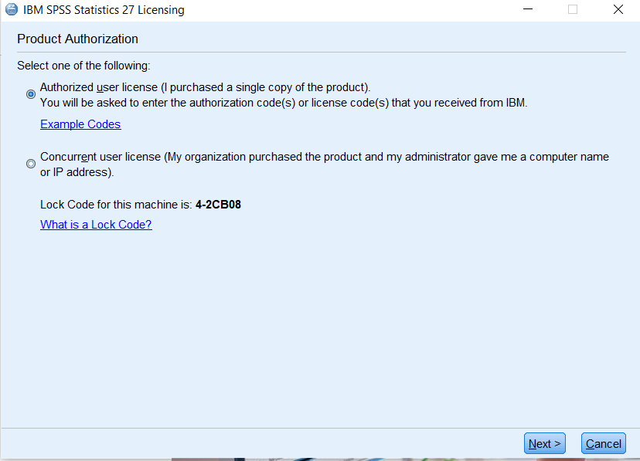

## SPSS Tutorials

<https://www.youtube.com/watch?v=_zFBUfZEBWQ>

## Variable naming in SPSS:

* No spaces – use an underscore instead
* Cannot begin with special chars (# @ &)
* Cannot begin with a number
* Max length 64 chars

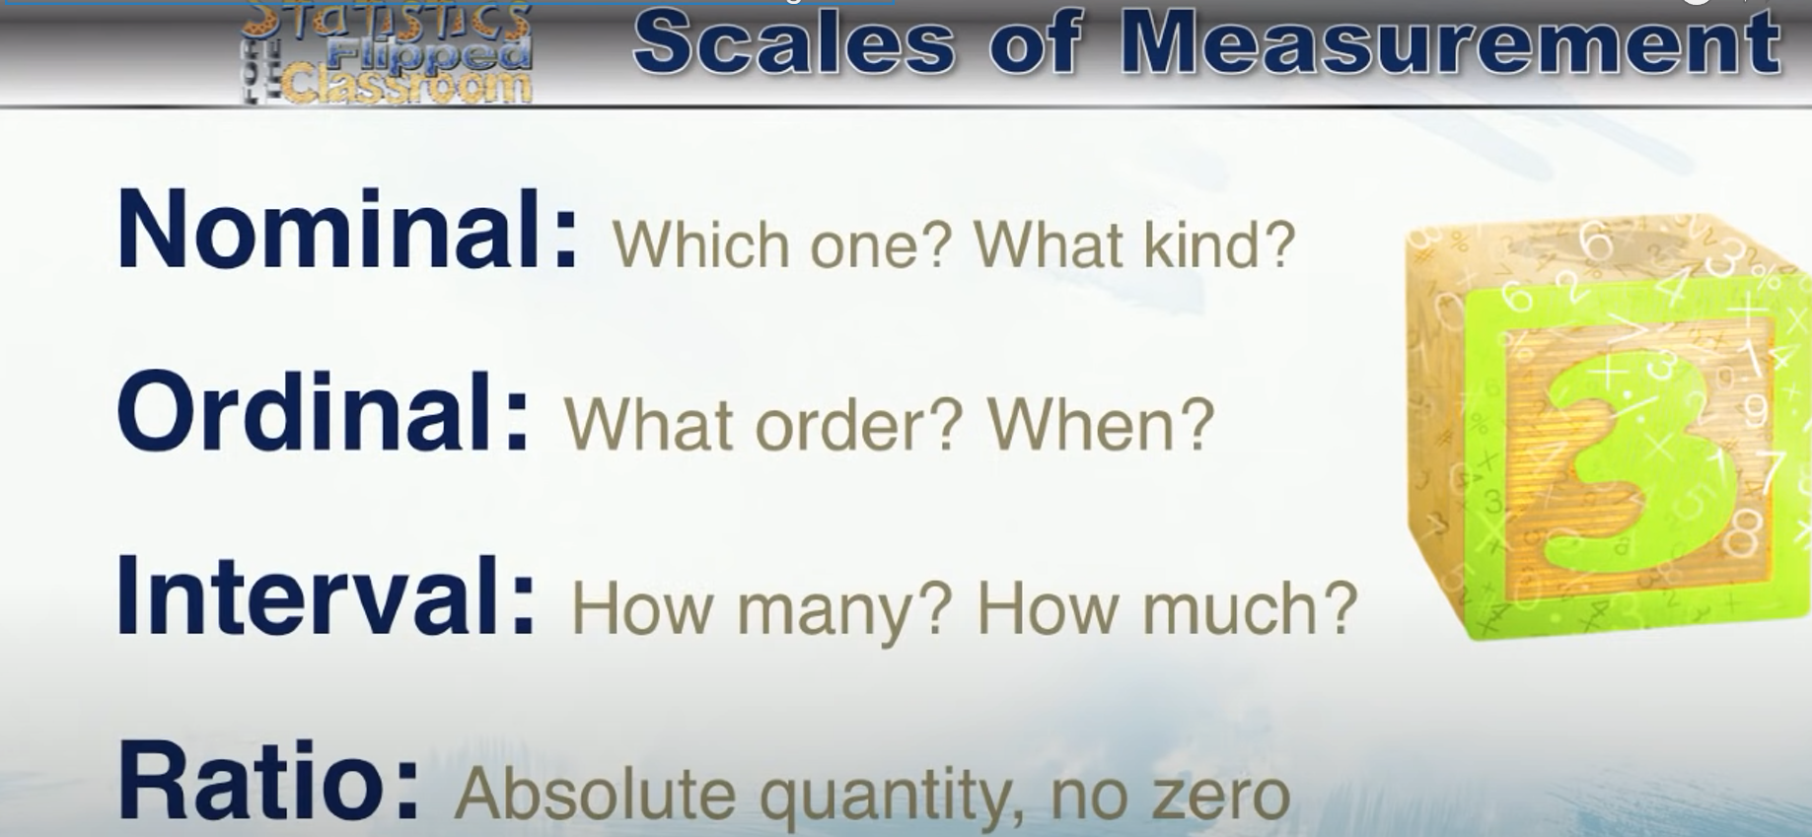

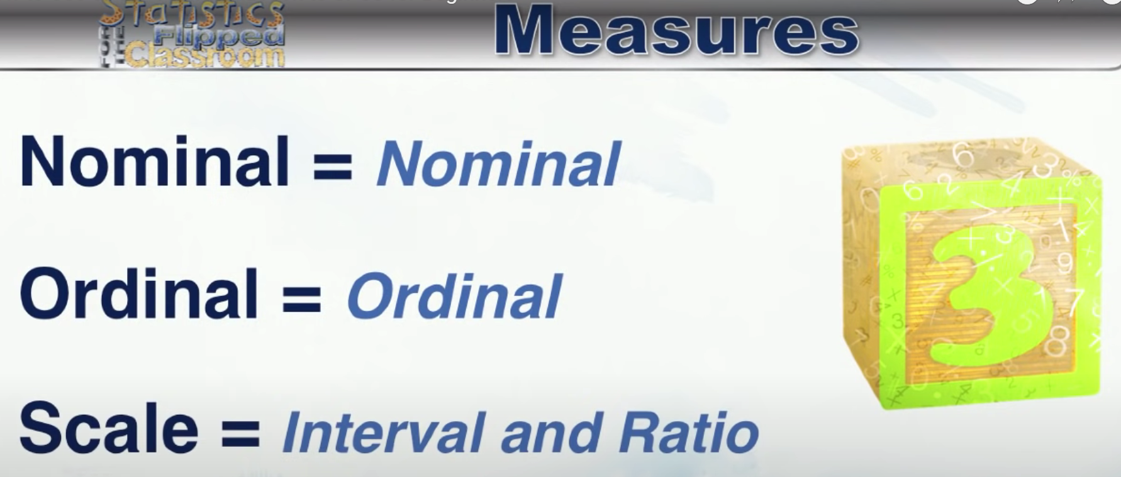



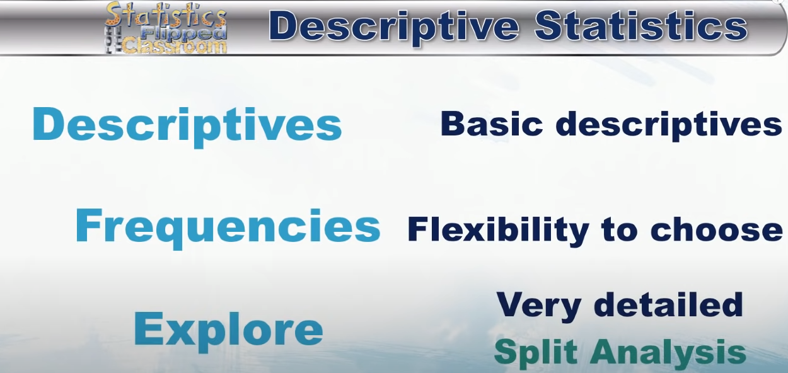

## Z Scores

For Z scores:

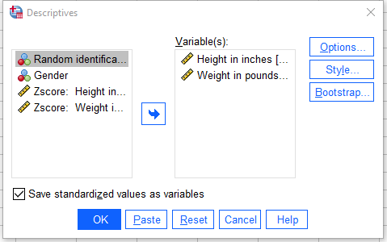

NEGATIVE Z score ➔ Below average

POSITIVE Z Score ➔ Above average

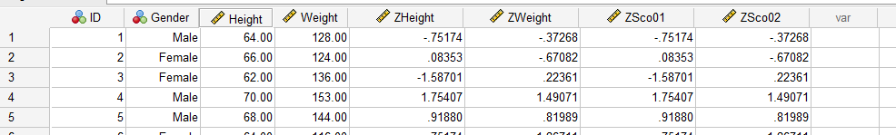

## Correlation with Pearson’s r

Measures the relationship between two variables.

Range -1 to +1

0 ➔ No relationship

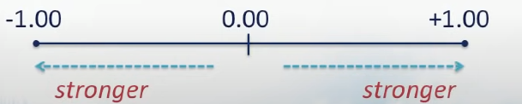

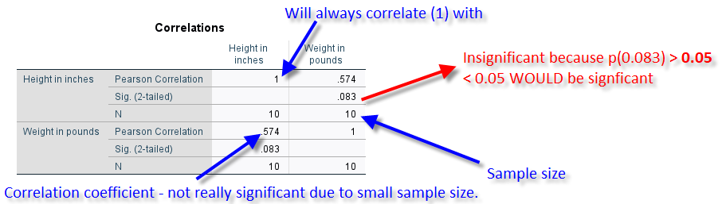

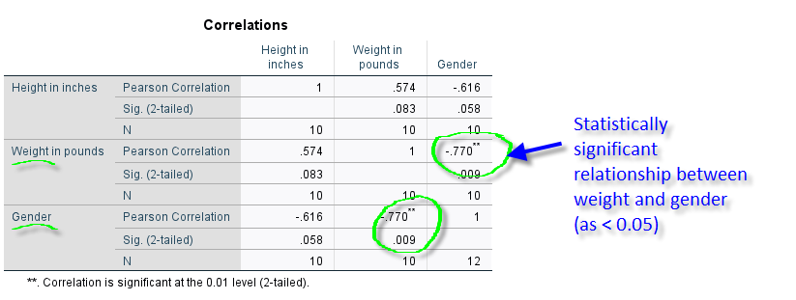

# Google Colab

<https://youtu.be/inN8seMm7UI>

Shift+ENTER = Run / Play

# Data Mining

Data mining is the process of discovering patterns in large data sets involving methods at the intersection of machine learning, statistics, and database systems. Data mining is an interdisciplinary subfield of computer science and statistics with an overall goal to extract information (with intelligent methods) from a data set and transform the information into a comprehensible structure for further use. Data mining is the analysis step of the knowledge discovery in databases process, or KDD. Aside from the raw analysis step, it also involves database and data management aspects, data pre-processing, model and inference considerations, metrics, complexity considerations, post-processing of highlighted structures, visualization, and online updating. The difference between data analysis and data mining is that data analysis is used to test models and hypotheses on the dataset, e.g., analyzing the effectiveness of a marketing campaign, regardless of the amount of data; in contrast, data mining uses machine- learning and statistical models to uncover clandestine or hidden patterns in a large volume of data.

* Data mining is more about **spotting patterns than explaining them**!

### Data mining techniques:

1. Classification
2. Regression
3. Clustering
4. Anomaly detection
5. Association learning

* **Classification**, e.g. probably pregnant Vs probably not pregnant.
* Many different classification algorithms.
* Can use feature **weights** in a NN to assign classification (fire Y or N as in are they in this category).
* **Regression** ➔ Instead or predicting a category, we want to predict a number e.g. time to giving birth (example above). It finds an equation of or curve to fit data points and estimates the slope at any point.
* More regression examples: Google searches analysis can predict how many people are suffering from the flu, going to commit a crime, etc., depending on the frequency of searches trending.
* **Clustering** ➔ To automatically group items, e.g. products. Can also be hierarchical clustering (categories), i.e. similar items with different variants.
* **Anomaly** **Detection** ➔ Fraud, tax evasion, safety mechanisms and diagnostics (e.g. aircraft)
* **Association** **learning** ➔ Men buying beer + nappies on a Friday evening

## Data Analytics

Wikipedia defines analytics as ‘the discovery, interpretation, and communication of meaningful patterns in data’ and that ‘entails applying data patterns towards effective decision making’.

**To find information about the information!**

Another, perhaps more detailed definition describes data analytics as;

‘the process of examining data sets in order to draw conclusions about the information they contain, increasingly with the aid of specialized systems and software. Data analytics technologies and techniques are widely used in commercial industries to enable organizations to make more informed business decisions and by scientists and researchers to verify or disprove scientific models, theories and hypotheses’.

<https://searchdatamanagement.techtarget.com/definition/data-analytics>

## Exploratory data analysis (EDA) Vs confirmatory data analysis (CDA)

* EDA aims to find patterns and relationships in data ➔ detective work
* CDA applies statistical techniques to determine whether hypotheses about a data set are true or false ➔ akin to the work of a judge or jury during a court trial
* Quantitative (numeric) Vs Qualitive (nominative) analysis

## Statistics and data science

A blog post by J. Megahan ‘[This is the difference between statistics and data science](https://mixpanel.com/blog/2016/03/30/this-is-the-difference-between-statistics-and-data-science/)’

“*Without an understanding of how people are using the product, and what the company goals are, the data analysis can get lost in translation. It’s a data scientist’s job to have all the things in her head all at once, so when someone comes to the department with a problem that isn’t very well defined, they know what data they have at hand to answer the question.*”

A journal paper by I. Carmichael and J. S. Marron entitled [Data science vs. statistics: two cultures](https://link.springer.com/article/10.1007/s42081-018-0009-3)

“*Data science is the business of learning from data, which is traditionally the business of statistics. Data science, however, is often understood as a broader, task-driven and computationally-oriented version of statistics.*”

## Data Science Process

### Tom Davenport

Stage 1 involves: (1) Problem recognition and (2) Review of previous findings.

Stage 2 involves: (3) Modelling, (4) Data collection and (5) Data analysis

Stage 3 involves: (6) Results Presentation

### CRISP-DM

The process underlying data analytics was established and formalized under the name of CRISP-DM in 1999. CRISP stands for Cross Industry Standard Process for Data Mining. Stages:

1. Business Understanding
2. Data Understanding
3. Data Preparation
4. Modelling
5. Evaluation
6. Deployment

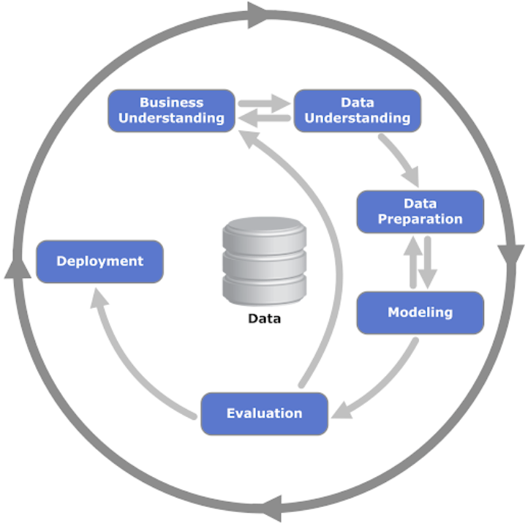

### KDD

KDD stands for knowledge discovery in databases and means ‘nontrivial extraction of implicit, previously unknown and potentially useful information from data stored in databases’. Stages:

1. Selection
2. Pre-processing
3. Transformation
4. Data mining
5. Interpretation/evaluation

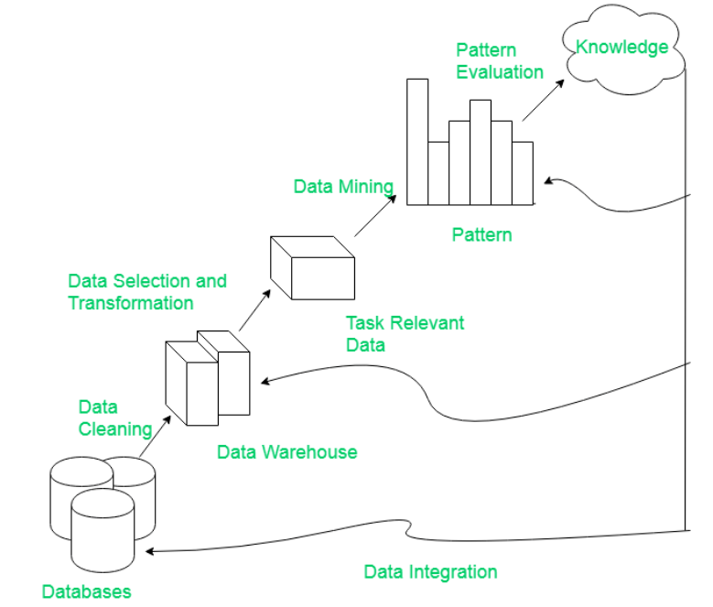

### TDSP

Team Data Science Process (TDSP) is a new data science methodology developed by Microsoft in 2016. It is based on well-known frameworks and leverages innovative tools such as git version control.

TDSP is an agile, iterative data science methodology to deliver predictive analytics solutions and intelligent applications efficiently.

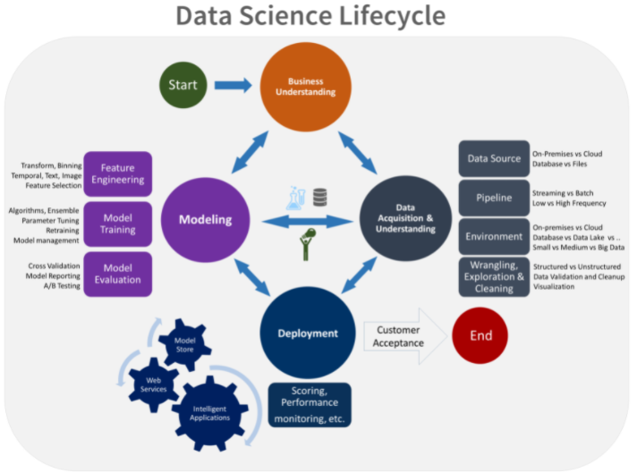

## Quiz

Question 1 – Is this statement true or false: Data analytics is the process of storing data.

* False

Question 2 – What is EDA?

* Exploratory Data Analysis

Question 3 – Qualitative data analysis is…

* the understanding of non-numerical data like text images, audio or video.

Question 4 – Select all of the correct answers. A data scientist…

* TRUE: Identifies relevant data sets needed for data analytics applications.
* TRUE: Communicates the results to business executives and other end users.
* TRUE: Works with others to collect, integrate and prepare data for analysis.
* TRUE: Develops trains and runs analytical models and assesses their findings.
* FALSE: Builds data pipelines to pull together data from different systems.
* FALSE: Structures and organizes data for use in specific applications.

Question 5 – Is this statement true or false? In data mining, you extract data itself.

* False

Question 6 – Is this statement true or false? KDD and CRISP-DM are 2 methods that help define the process of Data Analytics or Data Mining.

* True

Question 7 – Is this statement true or false? Data mining can unintentionally be misused by producing results that seem significant but yet have very poor predictive power.

* True

Question 8 – Is this statement true or false? KDD is the leading data mining standard

* False

Week 2 – Probability, regression and analysis of variance

# Week 2 – Probability, regression and analysis of variance

# Statistics - Overview

## 2.2 Descriptive and Inferential Statistics

In the previous topic, we touched on the relationship that statistics has with data analytics.

The video above, cover some very basic statistical concepts and will introduce concepts of Descriptive Statistics and Inferential Statistics. But let’s start with defining the term Statistics.

### Definition of Statistics

The practice or science of collecting and analysing numerical data in large quantities, especially for the purpose of inferring proportions in a whole from those in a representative sample.

Lexico

### Descriptive and Inferential Statistics

Descriptive Statistics are used to describe the numbers you have right in front of you and summarise these numbers as metrics or graphical displays. The average height of students in a class could be used as a means of describing student heights. Alternatively, one could summarise the range between maximum and minimum heights to describe the spread of the data.

Inferential statistics takes part in a population and attempts to infer something about the entire population. If I select a sample of 100 students from a university can I come up with an estimation for the overall average height within the university?

An excellent overview of descriptive statistics is provided in this article by Tomas Vetter:

[https://oce.ovid.com/article/00000539-201711000-00048/HTML#](https://oce.ovid.com/article/00000539-201711000-00048/HTML)

I have summarised them in the table:

|  |  |
| --- | --- |
| **Descriptive statistics** | **Inferential Statistics** |
| Describes the dataset that you are working with. | Makes inferences from the sample of the target population and generalises them. |
| Organises analyses and presents data in a meaningful way. | Compares, tests and predicts future outcomes. |
| Uses charts and tables to represent results. | Uses probability scores. |
| Describes data that is known. Can help us summarise data. | Leads to make conclusions about the population that is beyond data that is known. |
| Tools: Measures of central tendency (mean / median / mode), Data Spread (range, standard, deviation etc.) | Tools: Hypothesis test and analysis of variance |

See also:

[TO DO]

* Crash Course Statistics (an informative YouTube video by Crash Course Statistics):

<https://www.youtube.com/watch?v=sxQaBpKfDRk>

* Statistics: Descriptive and Inferential, TowardsDataScience.com (n article by Seema Singh on statistics: descriptive and inferential):

<https://medium.com/@seema.singh/statistics-descriptive-and-inferential-63661eb13bb5>

* Descriptive Statistics: Reporting the Answers to the 5 Basic Questions of Who, What, Why, When, Where, and a Sixth, So What?, by Thomas Vetter (an article by Thomas Vetter on reporting answers to the basic questions in descriptive statistics):

<https://oce.ovid.com/article/00000539-201711000-00048/HTML>

## 2.3 The Central Tendency

In statistics, a central tendency (or measure of central tendency) is a central or typical value for a probability distribution. It may also be called a centre or location of the distribution. The term central tendency dates from the late 1920s.

(Source: Wikipedia)

In the previous step, I asked you to read an article by Tomas Vetter Descriptive Statistics: Reporting the Answers to the 5 Basic Questions of Who, What, Why, When, Where, and a Sixth, So What? From that article, you should know that the mean, median, and mode are three measures of the central tendency of a set of data.

Let’s see how the author explained them and look at some examples.

### Mean

The mean can be described as the total sum of the values divided by the number of observations (sample size). Typically when someone asks us to describe a column of data, we would pick the mean because the mean gives an idea of the location of central point in the dataset. However, it is not the only measure of central tendency. **Distorted by outliers.**

### Mode

The mode is the discrete number or value that occurs most commonly or frequently in the dataset. It tells us the most fashionable value.

The mode is most useful when you have a relatively large sample so that you have a large number of the popular values. Can be used for non numeric values, e.g. we can tell the most popular colour but not the “mean colour”.

Bimodal or multimodal (more than two) data is useful where we have many values that are similarly common or significant.

E.g. **Multimodal** ➔ We might only want to review the best and worst ratings, i.e. 1 star and 5 stars, and forget the in between or average ratings.

E.g. **Bimodal** ➔ Say busiest restaurant times are lunchtime (13:00) and dinner time (18:00). Mean time (15:30) would mean nothing to us if we wanted to plan peak staffing requirements.

### Median

If you sort all the numbers highest to lowest, then the median is the value in the centre of these numbers. The 50th percentile and the median are effectively the same thing. One of the benefits of this measure is that it is **not affected by outliers**.

VIDEO: <https://youtu.be/kn83BA7cRNM>

### Distribution

Shows us how often a value occurs in our data set, i.e. frequency.

### Normal Distribution

A distribution of data that has roughly the same amount of data on either side of the middle and has most of its common values around the middle of the data, e.g. **bell curve**.

Median and mode are the same, i.e. has **zero skew**:

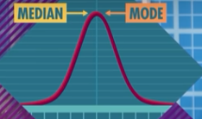

**Skewed** ➔ Median and mode are different, there may be imbalance of distribution. Mode stays highest and median stays in the middle, but the mean is pulled to unusual value:

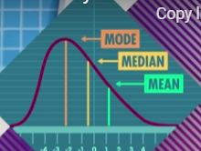

* Mean MUCH GREATER than median and mode ➔ Very large value(s) in data set
* Mean MUCH LESS than median and mode ➔ Very small value(s) in data set

**RULE: Always use the median when the distribution is skewed.** You can use either the mean or the median when the population is symmetrical, because then they will give almost identical results.

## 2.4 Dispersion and types of data

We are again going to refer to Vetter’s (2017) article mentioned in the previous steps and discuss dispersion and types of data.

In statistics, **dispersion** (also called **variability**, **scatter**, or **spread**) is the extent to which a distribution is stretched or squeezed. **Common examples of measures of statistical dispersion are the variance, standard deviation, and interquartile range**.

(Source: Wikipedia)

Measuring dispersion is really important when describing data. You will generally find that a measure of central tendency is not enough and understanding the spread of your data is really important also. This can quickly point out potential outliers in the data, or one can use dispersion range to calculate the likely future values.

Don’t be fooled into thinking that outliers should be excluded. Outliers can often be described as the data miners gold. Outliers required proper analysis; you cannot get rid of them unless you have sufficient hard proof they are incorrect.s

There are three measures of dispersion (more often called measures of spread):

1. **Range** is the difference between the largest and smallest number.
2. **Variance** is the difference between each data point and the mean, and this is then squared.
3. **Standard** **deviation** is the square root of the variance.

You may ask yourself why do we square the difference between the mean and the data point outlined in the variance. You may also ask yourself why the mean is used. Well, the reason is that by removing the mean we are effectively centralising the column around 0. These differences would have plus and minus signs. By squaring the differences we are now getting rid of the impact of the sign as a large plus is very similar to a large minus when trying to measure the dispersion.

### Types of Data

There are two major categories of data: **qualitative/categorical** and **quantitative/numerical**.

These terms are used interchangeably, and this is how I will be using them throughout the course.

### Qualitative or categorical data

Qualitative or categorical data is concerned with categories rather than numbers. It measures ‘types’ or categories and may be represented by a name, symbol, or code, for example, whether you’re married or single, live in Arkansas or Alabama or have blue eyes or brown eyes.

### Quantitative data

**Quantitative** or **numerical** **data** is, obviously, based on numbers. It is concerned with values or counts expressed as numbers. Numerical data can be further divided into two types:

**Continuous** **data**, that can be broken down into smaller and smaller numerical pieces. For example, is the temperature in your apartment at 69°F, or 69.4°F, or 69.123°F?

**Ordinal** **data**, that has natural ordered categories. For example, the ratings given in Yelp reviews.

### More on Qualitative Data

<https://www.simplypsychology.org/qualitative-quantitative.html>

Qualitative research is the process of collecting, analyzing, and interpreting non-numerical data, such as language. Qualitative research can be used to understand how an individual subjectively perceives and gives meaning to their social reality.

Qualitative data is defined as non-numerical data, such as text, video, photographs or audio recordings. This type of data can be collected using diary accounts or in-depth interviews, and analyzed using grounded theory or thematic analysis.

Qualitative research is multimethod in focus, involving an interpretive, naturalistic approach to its subject matter. This means that qualitative researchers study things in their natural settings, attempting to make sense of, or interpret, phenomena in terms of the meanings people bring to them.

### More on Quantitative Data

<https://www.simplypsychology.org/qualitative-quantitative.html>

Quantitative research involves the process of objectively collecting and analyzing numerical data to describe, predict, or control variables of interest.

The goals of quantitative research are to test causal relationships between variables, make predictions, and generalize results to wider populations.

Quantitative researchers aim to establish general laws of behavior and phenonomon across different settings/contexts. Research is used to test a theory and ultimately support or reject it.

## 2.8 aBox and whisker plots

Box and whisker plots are one of the most convenient ways to visually display data distribution. You can think about Box and whisker as the visual version of .describe() as they describe:

* Minimum
* Maximum
* Median (overall)
* Lower quartile median (Q1)
* Upper quartile median (Q3)

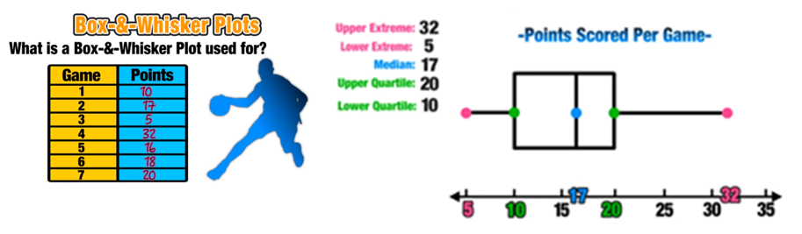

VIDEO: <https://youtu.be/R4yfNi_8Kqw>

## 2.9 Measures of spread

I briefly mentioned the measures of spread in Step 2.4, when talking about dispersion (also called variability, scatter, or spread). The measures of spread can help you to understand how well medians and means describe the data, and how reliable your conclusions are. There are three measures of spread:

1. **Range** (total) is the difference between the largest and smallest number.

1.1 **Interquartile range** doesn’t consider the outlying data / extremes, only includes middle 50%.

1. **Variance** is the difference between each data point and the mean, squared.
2. **Standard deviation** is the square root of the variance.

Some very different datasets may have the same mean and median, which effectively make their measures of central meaningless. In such cases, we are more interested in measures of spread.

VIDEO: <https://youtu.be/R4yfNi_8Kqw>

### Interquartile Range

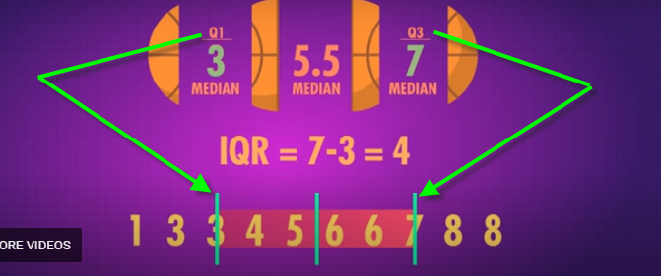

### Variance

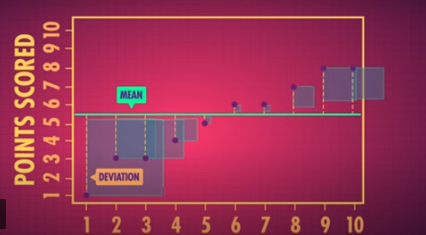

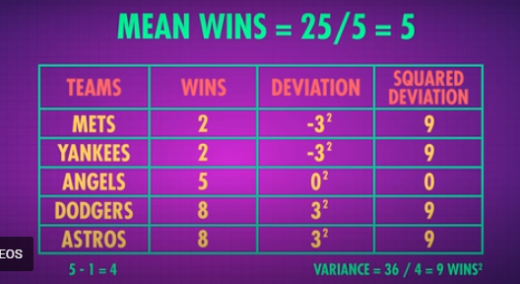

### Standard Deviation

Think of it as the average amount we expect a point to differ (or deviate from) the mean. **The bigger the standard deviation, the less accurate (or useful) the mean**. In other words, most data should cluster around the mean values if it is a “good” mean – the standard deviation should preferably be small. It is **effected by outliers**.

### Real life uses for measures of spread

* **Tests scores:** how did you did do compared to others?
* **Economists:** study income variation or inequality
* **Investors:** Identify price bubbles
* **Gamblers:** how much they might win or lose
* **Opinion Pollsters:** calculate margins of error

# Probability Laws

## 2.10 What is probability?

At the most basic level, probability seeks to answer the question, “What is the chance of an event happening?”

To calculate the chance of an event happening, we also need to consider all the other events that can occur. The quintessential representation of probability is a simple coin toss. In a coin toss, the only events that can happen are flipping heads or flipping tails. These two events form the sample space, the set of all possible events that can occur.

To calculate the probability of an event occurring, we count how many times an event of interest can occur (say flipping heads), and dividing it by the sample space. Thus, probability will tell us that an ideal coin will have a 1-in-2 chance of being heads or tails.

By looking at the events that can occur, probability gives us a framework for making predictions about how often events will happen. However, if we try to toss a coin, we may be likely to get an abnormally high or low count of heads every once in a while. If we don’t want to make the assumption that the coin is fair, what can we do? We can gather data! We can use statistics to calculate probabilities based on observations from the real world and check how it compares to the ideal.

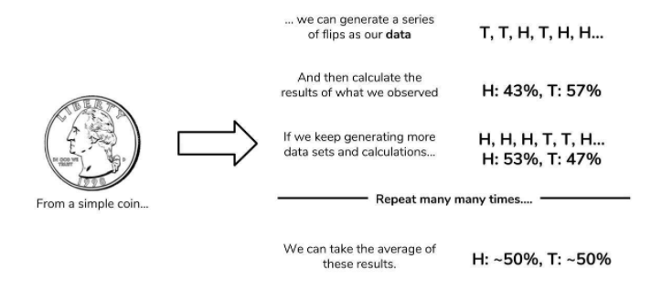

## From statistics to probability

Our data will be generated by flipping a coin ten times and counting how many times we get heads. We will call a set of ten coin tosses a trial. Our data point will be the number of heads we observe. We may not get the “ideal” 5 heads, but we won’t worry too much since one trial is only one data point. If we perform many, many trials, we expect the average number of heads over all of our trials to approach the 50%.

The code in this Colab simulates 10, 100, 1000, and 1,000,000 trials, and then calculate the average proportion of heads observed. Our process is summarised in the image below as well.

Frequently in business research, the analyst is interested in the likelihood that a particular event will occur. Some examples of that are:

* what is the chance that sales revenue will be higher than €100,000 next month and
* how likely is it that an item produced by a machine will be defective?

These questions can be answered, subjectively, based on a person’s or group of people’s belief or objectively (mathematically) using Probability Theory.

The purpose of Probability Theory is to try to calculate the probability of a given event occurring.

Suppose that an Event A can happen in k ways out of possible n outcomes. Then the probability of event A occurring is defined to be:

**P(A) = $\frac{k}{n}$**

* P(A) = Probability of Event A occurring

_

* P(A) = Probability of Event A not occurring
* P(A or B) = Probability of either Event A or Event B occurring
* P(A and B) = Probability of both Events A and B occurring
* P(A/B) = The Probability of Event A occurring given that Event B has already occurred. This is called the conditional probability

# Definitions

### An event

An event is defined to be an outcome or a group of outcomes from a single random experiment or several experiments.

#### Mutually exclusive events

Two or more events called mutually exclusive if the occurrence of any one of them excludes the possible occurrence of the others.

E.g. **Skittles** can be red or blue or green or yellow… can only be one colour! Can’t get two or more colours, i.e. probality is 0. However, probability of getting either blue or red is:

**P(blue OR red) = P(blue) + P(red)**

#### Non-Mutually exclusive events

E.g. **Skittles** plus **dice**. Getting a green skittle AND rolling a six are no mutually exclusive events.

**P(green OR six) = P(blue) + P(six) - P(green AND six)**

#### Independent events

Two events are called independent if the occurrence of one event does not affect the probability of the second event occurring.

Empirical probability

Derived or perceived from data samples, it’s a good estimation of theoretical or true probablility.

VIDEO: <https://youtu.be/OyddY7DlV58>

### Probability Rules

1. Probability of an event will always take a value between 0 and 1.
2. The sum of the probabilities for all possible outcomes of an experiment is equal to 1.

_

1. P(A) = 1 - P(A)
2. For two **mutually exclusive events**, A and B, the probability of either event A or event B occurring is given:

P(A or B) = P(A) + P(B)

If events are **not mutually exclusive**:

P(A or B)= P(A) + P(B) - P(A and B)

1. For two **independent events**, e.g. probability of it raining AND Liverpool winning tomorrow, the probability of one event occurring is not changed by whether or not the second event occurs. The probability of event A and event B occurring is given by:

P(A and B) = P(A) * P(B)

Events may be **not independent**, e.g. probability of a specific yet unpicked lottery ball changes every time another lottery ball is taken out. (If the balls were always put back then it would be independent.) Then probability of an non-independent event is:

P(A and B) = P(A) * P(B/A)

## Example

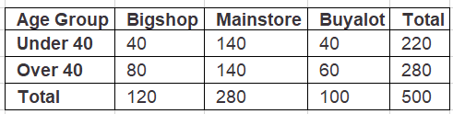

Probablities of:

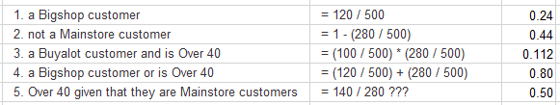???

# Distributions

## 2.11 Random variable

Probability and Statistics are the foundational pillars of Data Science. In fact, the underlying principle of machine learning and artificial intelligence is nothing but statistical mathematics and linear algebra.

In Data Science, you often encounter situations where to understand a particular topic, you need to read some research paper which involves a lot of maths. Because of that, to becoming a better Data Scientist, requires a strong mathematical understanding.

This step is about probability distributions. This term is commonly used in machine learning literature. If you are a beginner, then this is the right place for you to get started, as it will help you to learn about probability jargons like random variables, density curve, probability functions, etc.

Learn about different probability distributions and their distribution functions along with some of their properties.

Learn to create and plot these distributions in Python.

### Random Variables

A random variable is a variable whose possible values are numerical outcomes of a random phenomenon.

There are two types of random variables: discrete and continuous.

### Discrete random variables

A discrete random variable is one which may take on only a countable number of distinct values and thus can be quantified. For example, you can define a random variable to be the number which comes up when you roll a fair dice. can take values : [1,2,3,4,5,6] and therefore is a discrete random variable.

The probability distribution of a discrete random variable is a list of probabilities associated with each of its possible values. It is also sometimes called the probability function.

To have a mathematical sense, suppose a random variable may take k different values, with the probability that =xi defined to be P(=xi)=pi . Then the probabilities pi must satisfy the following:

**1: 0<pi <1 for each i**

**2: p1+p2+…+pk=1**

Among the examples of discrete probability distributions are:

* Bernoulli distribution
* Binomial distribution
* Poisson distribution
* etc.

### Continuous random variables

A continuous random variable Xi takes an infinite number of possible values. For example, you can define a random variable X to be the height of students in a class. Since the continuous random variable is defined over an interval of values, it is represented by the area under a curve (or the integral).

The probability distribution of a continuous random variable, known as probability distribution functions, are the functions that take on continuous values. The probability of observing any single value is equal to 0 since the number of values which may be assumed by the random variable is infinite. For example, a random variable may take all values over an interval of real numbers. Then the probability that is in the set of outcomes A, P(A), is defined to be the area above A and under a curve. The curve, which represents a function p(x), must satisfy the following:

1. **The curve has no negative values (p(x)>0 for all x)**
2. **The total area under the curve is equal to 1.**

A curve meeting these requirements is often known as a density curve.

Among the examples of continuous probability distributions are:

* normal distribution,
* exponential distribution,
* beta distribution, etc.

There’s another type of distribution that often pops up in literature which you should know about called cumulative distribution function. All random variables (discrete and continuous) have a cumulative distribution function. It is a function giving the probability that the random variable is less than or equal to x, for every value x. For a discrete random variable, the cumulative distribution function is found by summing up the probabilities.

## 2.12 Distributions types - the shape of data

When we use the term distribution in statistics, we usually mean a probability distribution - a mathematical function that provides the probabilities of the occurrence of various possible outcomes in an event or experiment.

In the next step, we are going to look closer at several types of distribution:

### Continuous probability distributions

* Uniform Distribution
* Normal Distribution (Gaussian)
* Exponential Distribution

### Discrete probability distributions

* Poisson Distribution
* Binomial Distribution

VIDEO: <https://youtu.be/bPFNxD3Yg6U>

### Normal Distribution or Bell Curve

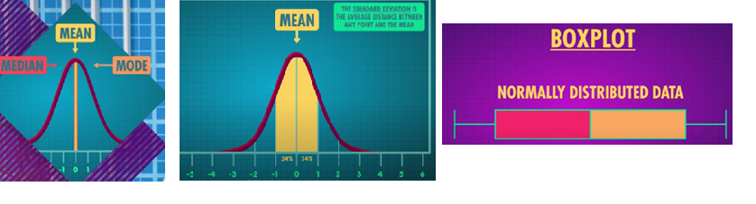

Unimodal (one peak)

* Mean, median and mode are the same and highest point
* Distribution is symmetrical

Outliers can skew the distribution away from normal:

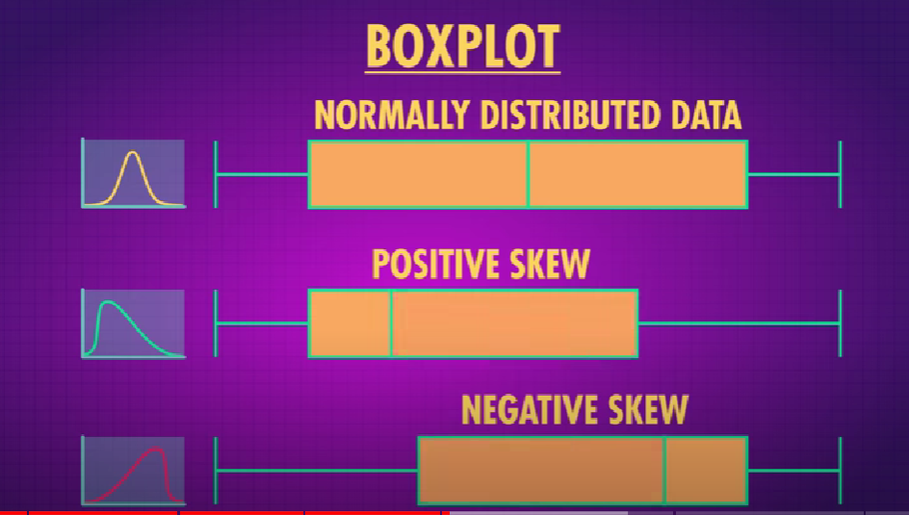

### Uniform Distribution

E.g. heads or tails, rolling dice, roulette… Every output should have equal chance in theoretical distribution. (That’s not to say it will turn out that way in reality!)

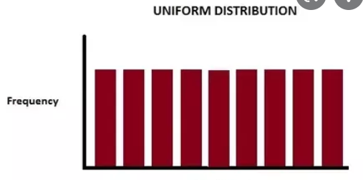

## 2.13 Uniform distribution

One of the simplest and most useful distribution types is the uniform distribution.

VIDEO: <https://youtu.be/3C9mpj-NYgo>

**U(a,b) reads: “uniform distribution of range a to b”**

The probability distribution function of the continuous uniform distribution is:

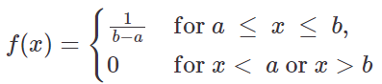

Since any interval of numbers of equal width has an equal probability of being observed, the curve describing the distribution is a rectangle, with constant height across the interval and 0 height elsewhere.

**The mean and variance are uninterpretable and possess no predictive power whatsoever.**

Since the area under the curve must be equal to 1, the length of the interval determines the height of the curve. The following figure shows a uniform distribution in interval (a,b). Notice since the area needs to be 1, the height is set to 1/(b-a)

**for a < x < b,**

**for x < a or x > b**

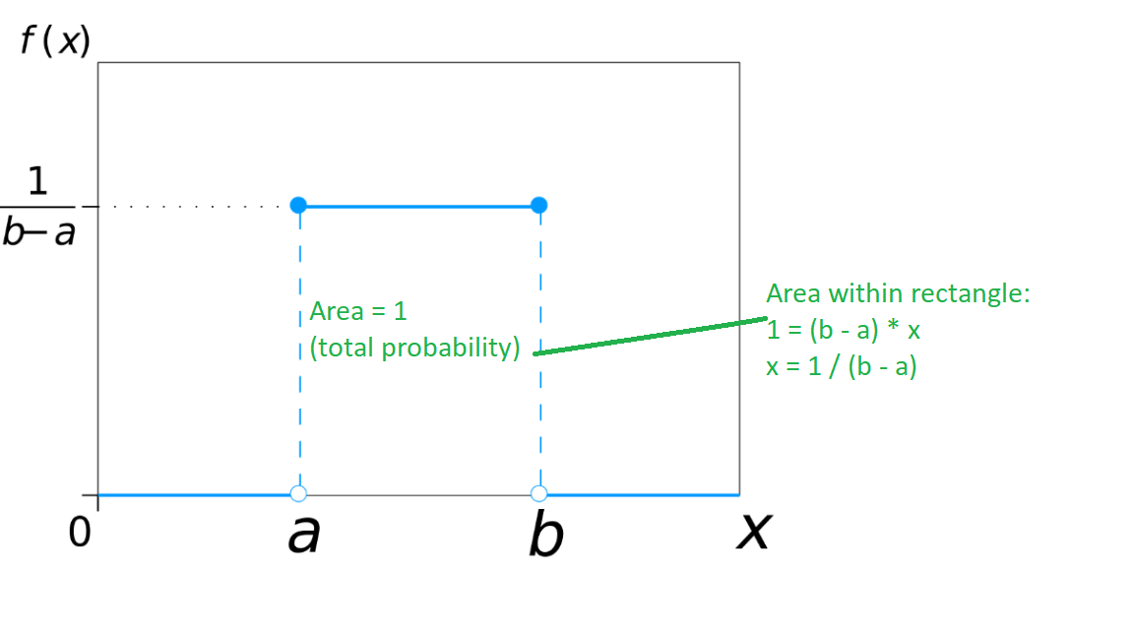

## 2.14 Normal distribution

A normal distribution, also known as Gaussian distribution, is ubiquitous in Data Science. You will encounter it in many places, especially in topics of statistical inference. It is one of the assumptions of many data science algorithms too.

A normal distribution has a bell-shaped density curve described by its mean μ and standard deviation σ. The density curve is symmetrical, centred about its mean, with its spread determined by its standard deviation showing that data near the mean are more frequent in occurrence than data far from the mean. The probability distribution function of a normal density curve with mean μ and standard deviation σ at a given point x is given by:

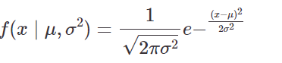

Below is the figure describing what the distribution looks like:

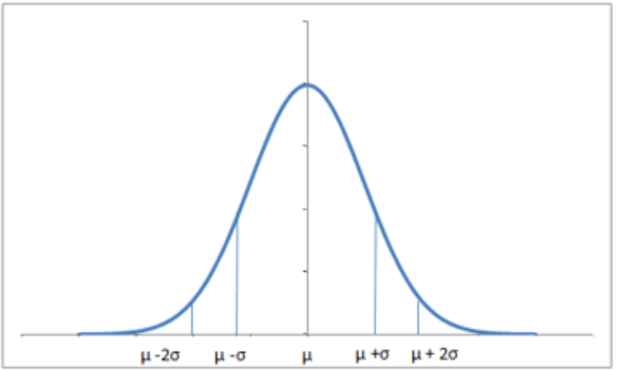

Almost 68% of the data falls within a distance of one standard deviation from the mean on either side and 95% within two standard deviations. Also, it is worth mentioning that distribution with mean 0 and standard deviation 1 is called a standard normal distribution.

You can generate a normally distributed random variable using scipy.stats module’s norm.rvs() method. The loc argument corresponds to the mean of the distribution, scale corresponds to standard deviation and size to the number of random variates. If you want to maintain reproducibility, include a random_state argument assigned to a number.

The normal distribution is significant to probability and statistics thanks to two factors: the Central Limit Theorem and the Three Sigma Rule.

### Central Limit Theorem

In the previous section, we demonstrated that if we repeated our 10-toss trials many, many times, the average heads-count of all of these trials will approach the 50% we expect from an ideal coin. With more trials, the closer the average of these trials approach the true probability, even if the individual trials themselves are imperfect. This idea is a key tenet of the Central Limit Theorem. In our coin-tossing example, a single trial of 10 throws produces a single estimate of what probability suggests should happen (5 heads). We call it an estimate because we know that it won’t be perfect (i.e. we won’t get 5 heads every time).

**If we make many estimates, the Central Limit Theorem dictates that the distribution of these estimates will look like a normal distribution.** The zenith of this distribution will line up with the true value that the estimates should take on. In statistics, the peak of the normal distribution lines up with the mean, and that’s exactly what we observed. Thus, given multiple “trials” as our data, the Central Limit Theorem suggests that we can hone in on the theoretical ideal given by probability, even when we don’t know the true probability. Central Limit Theorem lets us know that the average of many trials means will approach the true mean, the Three Sigma Rule will tell us how much the data will be spread out around this mean.

### Three Sigma Rule

The Three Sigma rule, also known as the empirical rule or **68-95-99.7** rule, is an expression of how many of our observations fall within a certain distance of the mean. Remember that the standard deviation (a.k.a. “sigma”) is the average distance an observation in the dataset is from the mean. The Three Sigma rule dictates that given a normal distribution:

* 68% of your observations will fall between one standard deviation of the mean.
* 95% will fall within two standard deviations of the mean.
* 99.7% will fall within three standard deviations of the mean.

A lot of complicated math goes into the derivation of these values, and as such, is out of the scope of this article. The key takeaway is to know that the Three Sigma Rule enables us to know how much data is contained under different intervals of a normal distribution.

VIDEO: <https://youtu.be/rBjft49MAO8>

* If you take several samples from the same population you should, in theory, come up with similar values for the means if it is a normal distribution.
* **With a large enough sample, any distribution with finite variance will have a distribution of means that is approximately normal.**
* **Standard error:** How different our sample mean is from the true mean.
* The bigger your sample size, the closer your sample mean gets to the true population mean.
* Standard deviation of sample size decreases as the sample size (n) increases:



## 2.15 Exponential distribution

The exponential distribution describes the time between events in a Poisson point process, i.e., a process in which events occur continuously and independently at a constant average rate. It has a parameter λ called rate parameter, which is the average, and its equation is described as:

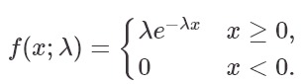

A decreasing exponential distribution looks like:

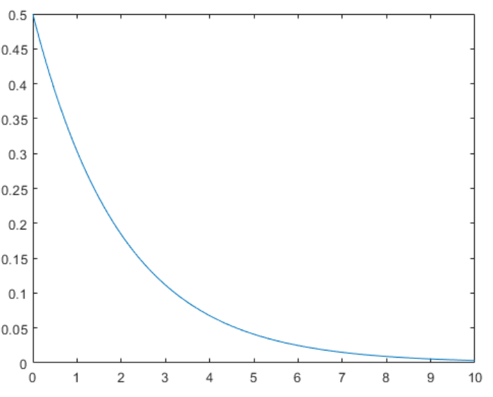

You can generate an exponentially distributed random variable using scipy.stats module’s expon.rvs() method which takes shape parameter scale as its argument which is nothing but 1/lambda in the equation. To shift distribution use the loc argument, size decides the number of random variates in the distribution. If you want to maintain reproducibility, include a random_state argument assigned to a number.





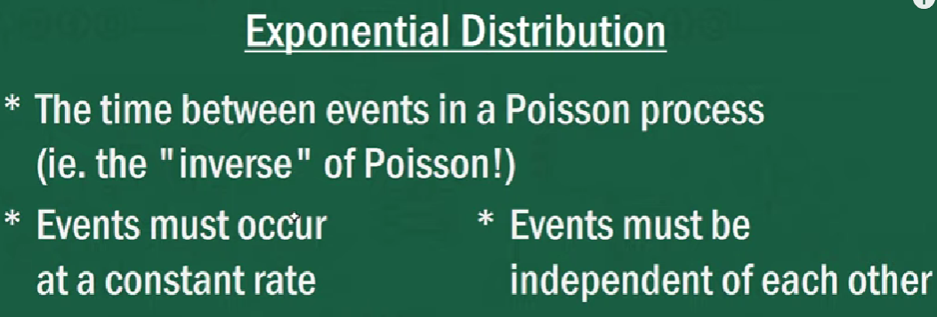

**Poisson 🡺 Discrete**

**Exponential 🡺 Continuous**

**PMF** = Probability Mass Function

**PDF** = Probability Density Function

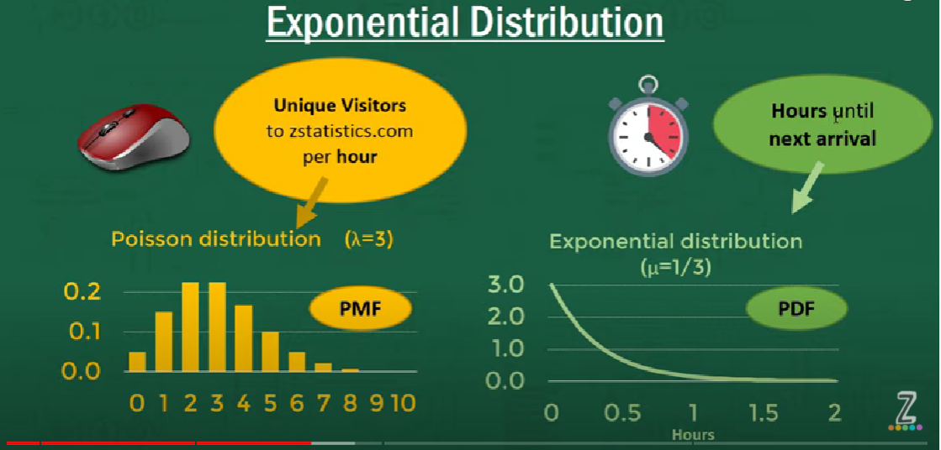

Cumulative Distribution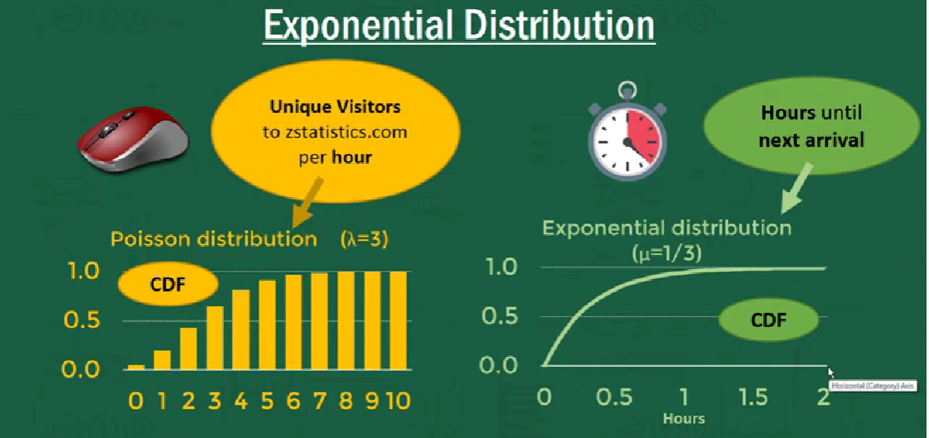

Area under the curve is 1

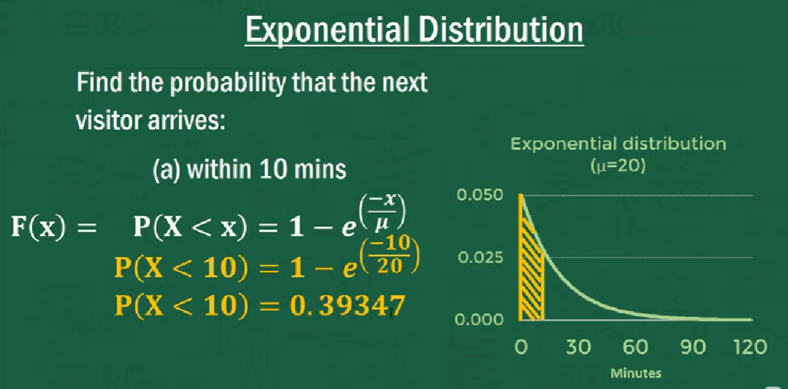

VIDEO: <https://youtu.be/2kg1O0j1J9c>

## 2.16 Poisson distribution

The Poisson distribution is popular for counting the number of occurrences of an event in an interval of time, distance, area or volume. But **it is an approximation of the true underlying reality**. It can sometimes be difficult to determine whether or not a variable has a Poisson distribution.

In probability theory and statistics, the Poisson distribution, named after French mathematician Siméon Denis Poisson, is a **discrete probability distribution** that expresses the probability of a given number of events occurring in a fixed interval of time or space if these events occur with a known constant rate and independently of the time since the last event. The Poisson distribution can also be used for the number of events in other specified intervals such as distance, area or volume.

Examples:

* the number of users visited on a website in an interval
* the number of Airbus 330 aircraft engine shutdowns per 100,000 flight hours.
* the number of asthma patient arrivals in a given hour at a walk-in clinic.
* the number of hungry persons entering McDonald's restaurant per day.
* the number of work-related accidents over a given production time.
* The number of dandelions in a square plot of land (**note doesn’t have to be time inteval!**)

### Criteria for Poisson Distribution

* Events must be independent, i.e. have no bearing on each other’s probability of occurring.
* However, the theoretical rate at which events occur does not change over time (averages out?)
* Summary: Events are occurring randomly and independently

The Poisson random variable is typically used to model the number of times an event happened in a time interval. For example, the number of users visited on a website in an interval can be thought of a Poisson process.

The Poisson random variable is typically used to model the number of times an event happened in a time interval. For example, the number of users visited on a website in an interval can be thought of a Poisson process.

Poisson distribution is described in terms of the rate μ (mu) at which the events happen. An event can occur 0, 1, 2, … times in an interval. The mean or average number of events in an interval is designated λ (lambda). Lambda is the event rate, also called the rate parameter. The probability of observing k events in an interval is given by the equation:

**μ** = mean of the random variable k, rate at which the events happen (number of occurrences per interval)

**λ** = event rate, a.k.a. rate parameter, i.e. average number of events in an interval

Note: **μ** = **λ** in Poisson distribution but we use **λ**

**σ2** = variance of the Poisson distribution

Note: **σ2** = **μ** = **λ**

**In a Poisson distribution, the mean and the variance are equal**

**e** = exponential constant, approximately **2.71828**

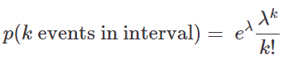

Note that the normal distribution is a limiting case of Poisson distribution with the parameter λ→∞. Also, if the times between random events follow an exponential distribution with rate λ, then the total number of events in a time period of length t follows the Poisson distribution with parameter λt. The following figure shows a typical Poisson distribution:

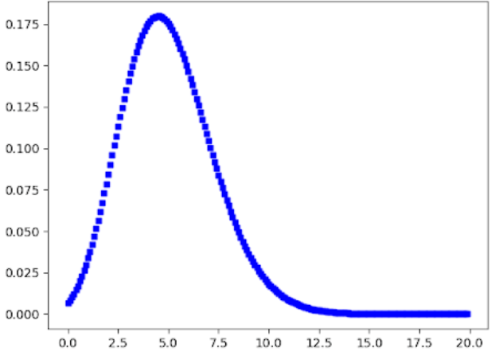

**Poisson distribution generally has some right skewness:**

* **λ mean LARGE 🡺** Distribution close to symmetric
* **λ mean close to zero** 🡺Right skewness strong

You can generate a Poisson distributed discrete random variable using scipy.stats module’s poisson.rvs() method which takes λ as a shape parameter. To shift distribution use the loc parameter. The command size decides the number of random variates in the distribution. If you want to maintain reproducibility, include a random_state argument assigned to a number.

VIDEO: <https://youtu.be/jmqZG6roVqU>

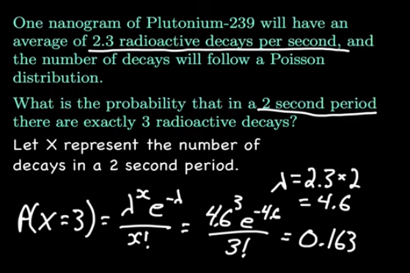

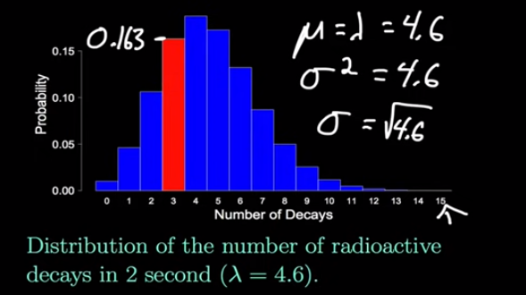

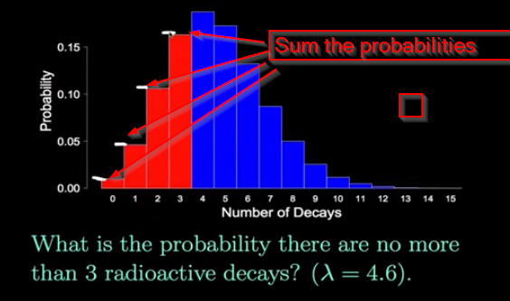

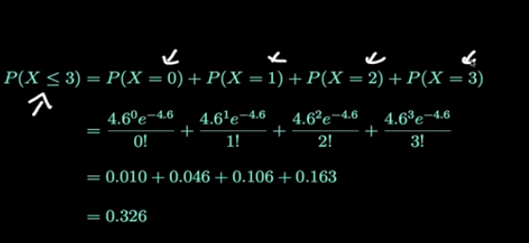

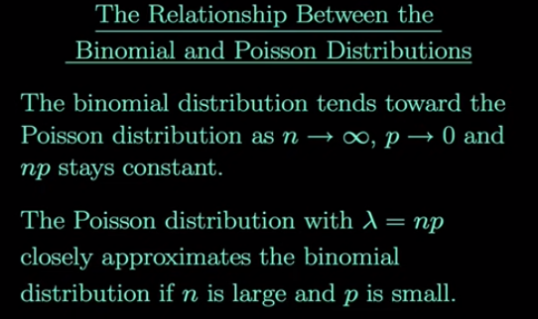

## 2.17 Binomial distribution

A **discrete** distribution where only two outcomes are possible, such as success or failure, gain or loss, win or lose and where the probability of success and failure is the same for all the trials is called a binomial distribution.

Examples:

1. A new drug is introduced to cure a disease 🡺 it either cures the disease (it’s successful) or it doesn’t cure the disease (it’s a failure).
2. You purchase a lottery ticket 🡺 you’re either going to win money, or you aren’t.

Basically, anything you can think of that can only be a success or a failure can be represented by a binomial distribution.

The **outcomes** need not be equally likely, and each trial is **independent of each other**. The parameters of a binomial distribution are n and p where n is the total number of trials, and p is the probability of success in each trial. Its probability distribution function is given by:

**n** = total number of trials

**p** = probability of success in each trial



Where:

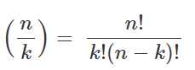

You can generate a binomial distributed discrete random variable using scipy.stats module’s binom.rvs() method which takes n (number of trials) and p (probability of success) as shape parameters. To shift distribution use the loc parameter. Size decides the number of times to repeat the trials. If you want to maintain reproducibility, include a random_state argument assigned to a number.

### Rules for Binomial Distribution

In order to know when a random variable in a statistical sample does not have a binomial distribution, you first have to know what makes it binomial. You can identify a random variable as being binomial if and only if the following four conditions are met:

1. There are a fixed number of trials (n).
2. Each trial has two possible outcomes: success or failure.
3. The probability of success (call it p) is the same for each trial.
4. The trials are independent, meaning the outcome of one trial doesn't influence that of any other.

VIDEO: <https://youtu.be/WR0nMTr6uOo>

### Example: Toaster

Chances of you getting an electric shock every time you use it (and you only use it Mon-Fri) are 1 / 5.

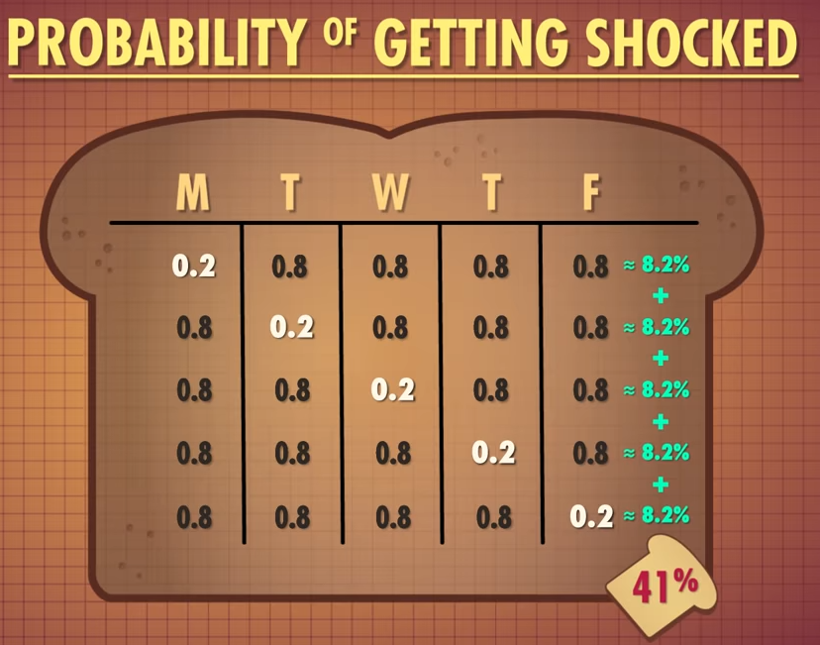

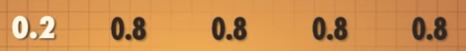



Chances of getting shocked only once:



Chances of getting shocked twice:

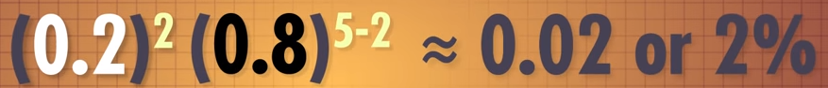

### Binomial Coefficient Formula

The Binomial Coefficient Formula makes it easy for us to find out how many ways a certain ratio of successes to failures can occur, e.g. not getting shocked to getting shocked above.

 **n Choose k**

**With n number of things, count the number of different ways can we can get k of them.**

E.g. for toaster giving us an electric shock out five days per week it’s **5C1 = 5**

🡺 There are 5 different ways we can receive a shock from our toaster this week!

formula behind nCk is:

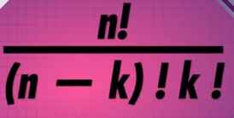

Probability of getting shocked 1 out of 5 days this week is:



**Note:** 5C1 is calculated using pink factorial formula for nCk above.

### Example: Zombies

The scenario – calculate your chances of making it through a crowd to safety when:

* 20 people outside
* Current infection rate = 5%
* Uninfected = 95%
* How likely is it that none of them have been bitten?

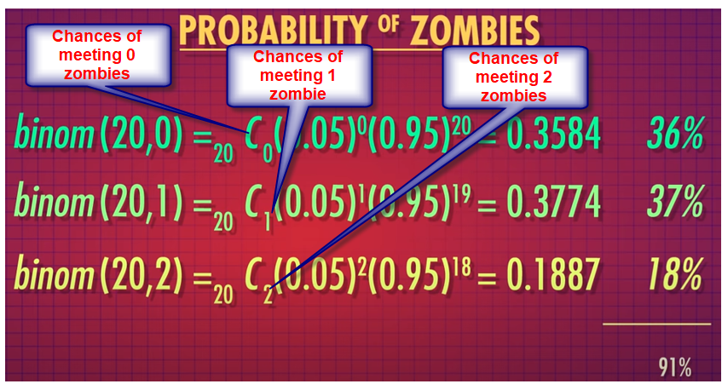

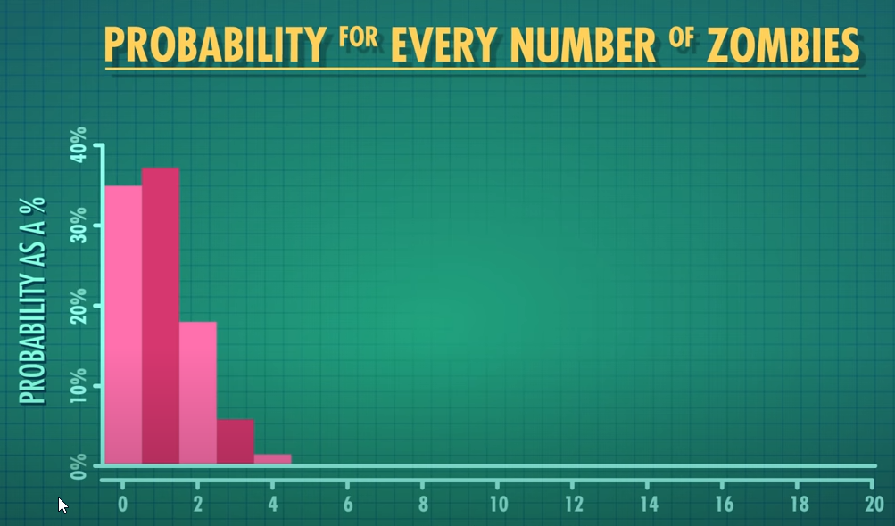

But what about the mean chances of encountering a zombie in population of 20?

For Binomial Distribution, **mean = N * P** where:

* N is number of events (20 in this case)
* P is probability of the occurrence (0.5 in this case)

5% chance in population of 20 🡺 0.05 * 20 = mean of 1 zombie infection

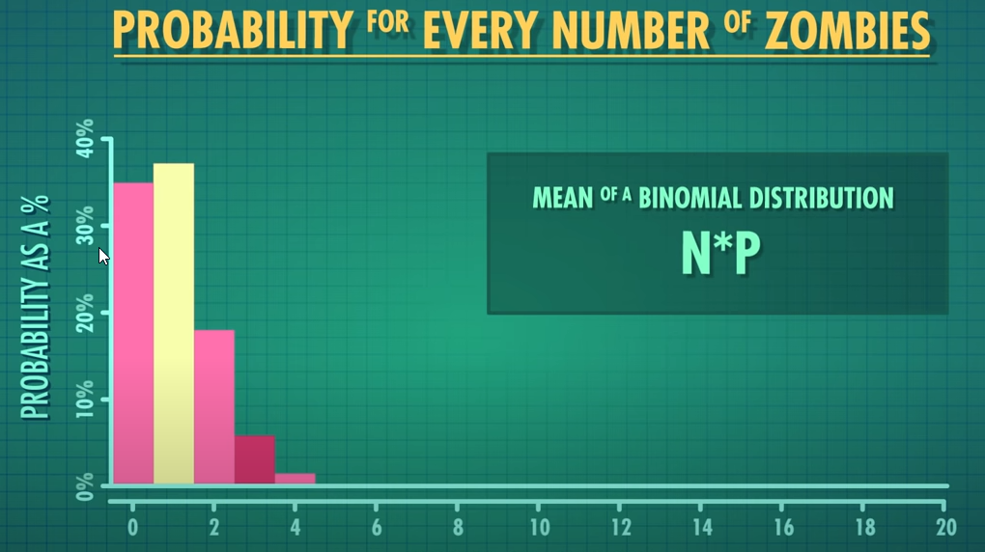

### Example: Common Cold

The scenario – calculate your chances of shaking hands with someone who has a cold:

* 40 people
* Current infection rate = 20%
* Uninfected = 80%
* How likely is it that someone you shake hands with has a cold?





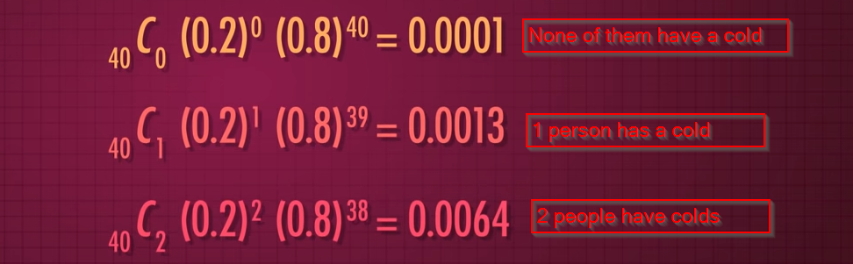

Chances of two people or less having a cold is only approximately 0.07% (0.0001 + 0.0013 + 0.0064)

i.e. very likely that 2 or fewer people HAVE a cold.

You would expect 8 people at any one time to have a cold in the population of 40,

i.e. **mean = 40 * 0.2 = 8**

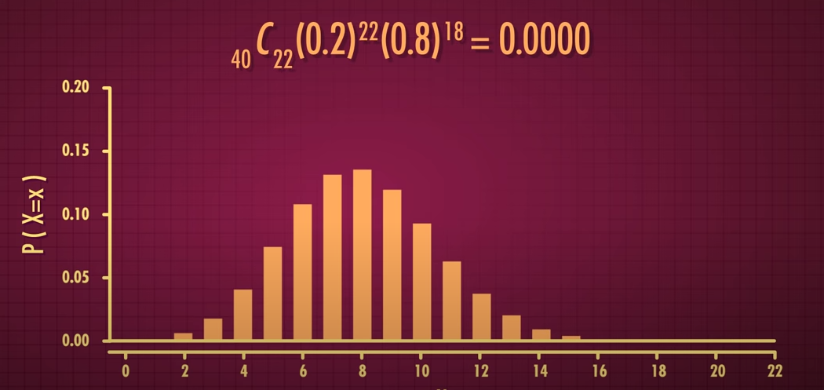

### Bernoulli Distribution

A special case of binomial distribution with only one trial – or just one event., e.g. a single coin flip – is called the Bernoulli Distribution. Represents the probability of getting a:

1 – Success

0 – Failure

Probability of success:

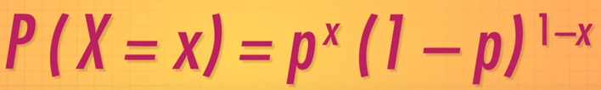

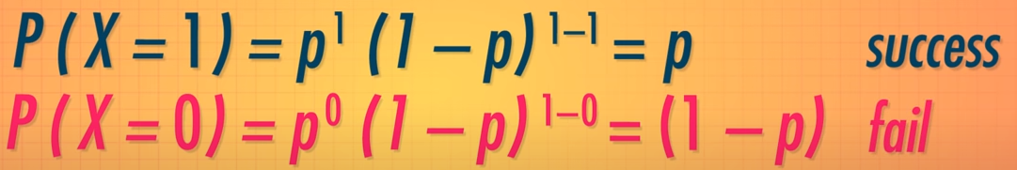

Example: Dice

Probability of rolling an odd prime number (3 or 5) on a single dice roll = 33.33%:



Failure to roll a 3 or a 5 = 

Success = 

## Quiz

**Question 1**

Which of the following statistics is a measure of dispersion?

* Mean and median.
* Standard deviation.
* Mean absolute deviation.
* Range.
* **Standard deviation.**

**Question 2**

A company has a security system comprising four electronic devices (A, B, C, and D) which operate independently. Each device has a probability of failure of 0.1. The four electronic devices are arranged so that the whole system operates properly if at least one of A or B functions and at least one of C or D functions. What is the probability that the whole system functions properly?

* (1-P(A and B failing)).(P(C and D failing)
* 1-(P(A and B failing)).(P(C and D failing))
* (1-P(A and B failing)).(1-P(C and D failing))
* Other.
* **(1-P(A and B failing)).(1-P(C and D failing))**

**Question 4**

A firm submits tenders for two different contracts. The probability that the first tender (A) will be successful is 60% and the probability that the second tender (B) will be successful is 40%. Calculate the probability that at least one bid is successful.

* (1-P(A)) + (1-P(B))
* 1-(P(A).P(B))
* (1-P(A)).(1-P(B))
* Other.
* **(1-P(A)).(1-P(B))**

**Question 5**

A confidence interval is a measure…

* of the dispersion of the sample.
* of the precision of a point estimate.
* of the precision of the size of the sample.
* Other.
* **of the precision of a point estimate.**

WEEK 3 - Statistical tests and modelling data

# WEEK 3 - Statistical tests and modelling data

# Statistical tests

## 3.2 Why do we need statistical tests?

In this section, we are going to review statistical testing. Before we delve into the topic, we would like you to think about how statistics are used in everyday life or how they can help you in your data analytics journey.

In many situations we use a sample to get a representation of the population. You will have seen this in political elections, where polls are conducted before an election. In this example, you will regularly hear about the margin of error. This means that the sample or poll is subject to % error that if we added or subtracted it from our sample proportion of votes, we would probably find the true proportion.

You will all have used medications or drugs during your life to cure a headache or some illness. Each of these drugs is tested using samples of patients who either take the drug or are given a placebo. These two groups were then compared using a statistical test. If the company proposing the drug did not find a statistically significant difference using an appropriate statistical test then the drug would not be permitted to be sold.

**Statistical testing allows us to make inferences about the true population from a sample. It is used in many areas including the social sciences, engineering and health for example.**

Can you think of any other situations where statistical testing could be used in your life?

Share your thoughts in the comment section below. You might consider the following prompts when posting your answer:

Do you think statistical testing could be useful in data analytics?

Why do you think so?

Can you give some other examples of how they are used?

## 3.3 Statistical tests

We live in the data and information world and we use statistics to keep us informed about what is happening in the world around us.

Many of us are now using sports equipment to record our training performances, or in the industry, we regularly measure key performance indicators. When we get a personal best does it really mean we have jumped forward with our training or is it just by chance that we got this result. Or when your company gets a great sales result is this really down to the marketing campaign or is it just by chance.

Statistical testing helps us to check a hypothesis or a prediction about a population parameter using an estimate of that parameter calculated from a sample of the population.

Statistical tests have many applications in business. They can, for example, help to analyse, whether:

* a marketing campaign has increased a company’s sales figures.
* a marketing campaign has increased a company’s market share (In many businesses, examples tests are used to examine differences between groups).
* males and females spend the same amount on magazines.
* urban or rural consumers are more likely to buy a product.
* consumers in France, Germany, Ireland and the UK have different views on what is important when buying a car.

### Why do we need statistical tests?

Consider the results of a survey that show that a sample of males spent an average of €20 a week on magazines and that a sample of females spent an average of €21 a week on magazines.

Does this prove that females spend more on magazines on average?

Not necessarily because we know that both results are only sample estimates. It is not possible to directly prove or disprove a hypothesis using sample estimates alone, because these statistics will have inherent sample errors.

So **we need some technique or techniques to help us decide whether a sample parameter provides enough evidence to prove a hypothesis about the population parameter. These techniques are called statistical tests or hypothesis tests.** These tests are designed to check if the sample results observed are statistically significant. Put simply, in the example above we would like to know if the difference between males and females was due to random chance or due to a significant difference in expenditure between them.

I would like you to consider how we could use statistical testing to determine if a data point is an outlier in our data. Does this make sense? Can you explain why? Post your answers in the comment section.

## 6 Steps of Statistical Testing

Regardless of the problem you have, the steps you need to follow will be the same or very similar for most statistical tests. You may want to test if your population mean is likely to be greater than some value, or that the proportion of people with a third level education is greater than 40%. The process is nearly always the same.

### 6 Steps of Statistical Testing

1. State the Null and Alternative Hypotheses
2. Set the precision level
3. Gather sample data and calculate sample statistics
4. Choose the appropriate Statistical Test
5. Calculate the Test Statistic
6. Interpret the Results of the Test / Examine the P-value

will explain the steps below and give you some real-life examples. I also have a Google Colab file set for you to practice completing a statistical test for the comparison of the mean between two groups using two samples.

#### 1. State the Null and Alternative Hypotheses

The first step is to outline the objectives of the test. The Null and Alternative Hypothesis are opposing statements about the population parameter being tested. In general, the researcher is trying to prove the Alternative Hypothesis by showing that the null hypothesis is false. For instance, consider HR Research Ltd. who are examining pay rates in two different sectors, A and B, to test if there is a difference between them using a sample of employees from both sectors. In this case, the null hypothesis would state that the Average Salaries in both sectors are equal, while the Alternative would state that the Average Salaries are not equal. Mathematically this can be written as:

**Null Hypothesis H0:**

 or 

(Average Salary is equal in both sectors)

**Alternative Hypothesis H1:**

 or 

(Average Salary is **not** equal in both sectors)

#### 2. Set the precision level

At the initial stage, the researcher will also set the level of precision for the test. This is the **level of confidence** the researcher wishes to achieve before rejecting the null hypothesis. The **95% confidence level is the accepted norm in Social Science and Business Research** although occasionally some researchers will use other levels (99%, 90% etc.). Please note that we can never be 100% confident about a sample result.

#### 3. Gather sample data and calculate sample statistics

To test the hypothesis, a sample of data is selected from the population, and the relevant sample statistics (mean, standard deviation, proportion, etc.) are calculated. In the HR Research Ltd. example shown below, they would calculate the relevant descriptive statistics for the problem. In this case, they would need the sample means, sample standard deviations and sample sizes.

X-bar is the sample mean: 

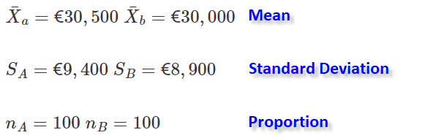

The t-statistic can be calculated using the following formula:

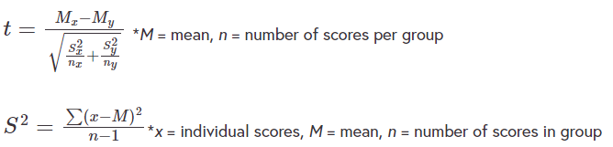

**T-test is good for identifying outliers.**

The simple python code for the above example is available in this Google Colab file:

<https://www.futurelearn.com/courses/intro-to-data-analytics/3/steps/1234422#:~:text=The%20simple%20python,the%20formulas%20above>.

Vary Na and Nb and and see what happens. Remember to check that you understand how the code relates to the formulas above.

#### 4. Choose the appropriate Statistical Test

To find the appropriate test, we must look at the type of variable we are testing and what the test is trying to show. In the HR Research Ltd. example, they are looking at a difference in salaries, so the test variable is a Salary, which is a Ratio variable. They are trying to compare the salaries in two sectors, A and B, so the test is a measure of the difference between the two groups. The appropriate test for this problem type is called an Independent Sample t-Test. We will look at a sample of some of the more widely used tests later in this section.

#### 5. Calculate the Test Statistic

To test the null hypothesis, the difference between the hypothesised value of the parameter and the sample value of the parameter is calculated. For instance, the null hypothesis for the HR Research Ltd. problem stated that the difference between salaries in the two sectors is equal to zero. However, they found in a survey that respondents in Sector A were earning on average €500 more than the respondents in Sector B. In order to test if this difference is statistically significant we calculate a test statistic (in this case a t-value). The test statistic is a measure of the relative size of the difference, taking into account the amount of variation in the data and the sample size. The t-value for the HR Research Ltd. data is equal to 0.386.

At the end of this section, we will briefly look at how two of these test statistics are calculated, but in general, this calculation is performed using appropriate statistical software.

#### 6. Interpret the Results of the Test / Examine the P-value

Unfortunately, there are a large number of test statistics, and they are not always easy to interpret, without detailed knowledge of how the particular test works. What for instance does a t-value equal to .386 tell us? Fortunately, due to developments in statistical software, there is a more straightforward way of interpreting the results of a statistical test, by using what is called the p-value of the test, which is common to all tests.

The p-value is an estimate of the probability of how far away something is from the mean.

P-value

P-value measures the probability of calculating the observed sample value if the null hypothesis was, in fact, true.

The decision to reject or “accept” the null hypothesis (to test if it is false) can be made by examining the p-value. Quite simply, **if the p-value is less than .05 then there is less than 5% of a chance that the null hypothesis is true** and **conversely more than a 95% chance that is false so that it can be rejected with 95% confidence**. However, if it is above .05, then the null hypothesis cannot be rejected at this level. The p-value for the HR Research study was .7, so we cannot reject the null hypothesis. It indicates that there is no evidence to suggest that there are significant salary differences between Sectors A and B. You will see the p-value that is calculated from the Google Colab code.

* p-value < 0.05 🡺 REJECT null hypothesis (and accept alternative hypothesis)
* p-value > 0.05 🡺 ACCEPT null hypothesis (and reject alternative hypothesis)

**Rule:** You can reject a null hypothesis but you can’t accept it on a single sample.

## 3.5 Popular statistical tests for differences

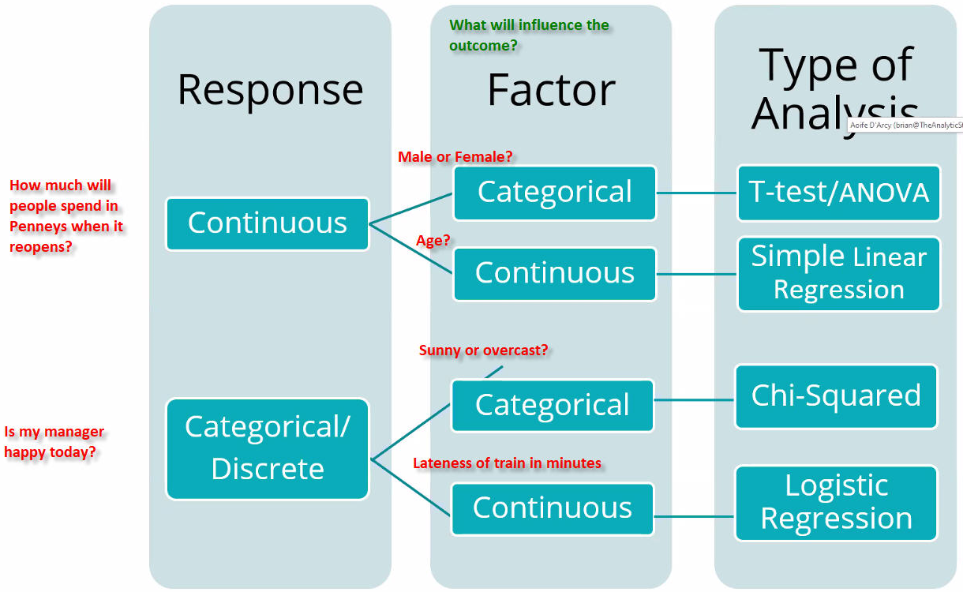There are many statistical steps used. Below, I listed some of them that are most widely used in many social science fields. I have also noted the context in which where they should be applied.

Statistical Test:

<https://towardsdatascience.com/statistical-tests-when-to-use-which-704557554740>

A null hypothesis, proposes that no significant difference exists in a set of given observations.

**Null** 🡺 Given two sample means are equal

**Alternate** 🡺 Given two sample means are not equal

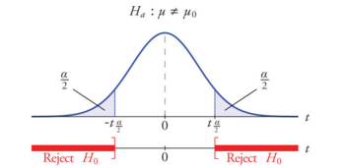

### Tests for differences between TWO independent groups

* **Nominal Variable - Chi-Square Test:**

<https://en.wikipedia.org/wiki/Chi-squared_test>

Pearson's chi-squared test is used to determine whether there is a statistically significant difference between the expected frequencies and the observed frequencies in one or more categories of a contingency table.

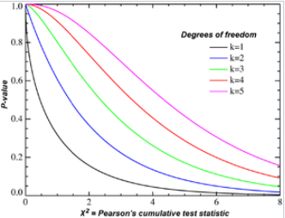

* **Ratio Variable - Independent Sample T-Test/Z-Test:**

The Independent Samples t Test compares he means of two independent groups in order to determine whether there is statistical evidence that the associated population means are significantly different.

<https://en.wikipedia.org/wiki/Z-test>

A Z-test is any statistical test for which the distribution of the test statistic under the null hypothesis can be approximated by a normal distribution. Z-tests test the mean of a distribution. For each significance level in the confidence interval, the Z-test has a single critical value (for example, 1.96 for 5% two tailed) which makes it more convenient than the Student's t-test whose critical values are defined by the sample size (through the corresponding degrees of freedom).

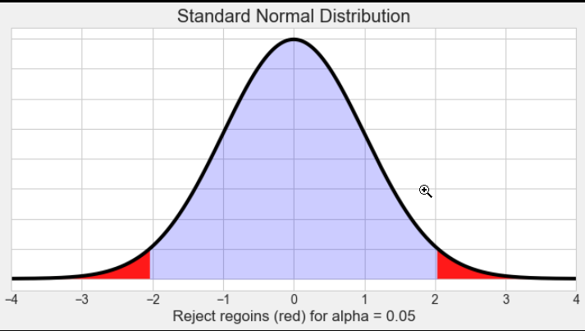

* **Ordinal Variable** - **Mann-Whitney U Test**:

This is a non-parametric test. This test can be used to investigate whether two independent samples were selected from populations having the same distribution.

<https://en.wikipedia.org/wiki/Mann%E2%80%93Whitney_U_test>

In statistics, the Mann–Whitney U test (also called the Mann–Whitney–Wilcoxon (MWW/MWU), Wilcoxon rank-sum test, or Wilcoxon–Mann–Whitney test) is a nonparametric test of the null hypothesis that, for randomly selected values X and Y from two populations, the probability of X being greater than Y is equal to the probability of Y being greater than X.

### Tests for differences between MORE THAN TWO independent groups

* **Nominal Variable - Chi-Square Test:**

As above

* **Ratio Variable – ANOVA:**

A **one-way ANOVA** is a type of statistical test that compares the variance in the group means within a sample whilst considering only one independent variable or factor, e.g.

A **two-way ANOVA** is, like a one-way ANOVA, a hypothesis-based test. However, in the two-way ANOVA each sample is defined in two ways, and resultingly put into two categorical groups, e.g.



It is a hypothesis-based test, meaning that it aims to evaluate multiple mutually exclusive theories about our data.

* **Ordinal Variable - Kruskal – Wallis:**

The Kruskal–Wallis test by ranks, or one-way ANOVA on ranksis a non-parametric method for testing whether samples originate from the same distribution. It is used for comparing two or more independent samples

One of the major decisions when choosing a statistical test is the assumptions that are made for each test. There are basically two families of test and they are:

1. **Parametric tests:** Have stricter assumptions than non-parametric but when these assumptions are met they give better and more accurate results and have a higher degree of accuracy.
2. **Non-parametric tests:** Have very little or no assumptions but are not as accurate as parametric tests.

## Three assumptions underlying statistical tests

Most statistical tests have several assumptions underlying them. It is essential to check these assumptions when using a test. Violations in assumptions can lead to making incorrect conclusions when interpreting the test results.

### 1. Parametric Tests (Normality assumption)

T-Tests and One-way Anova are from a family of parametric tests, which is based on the assumption that the test variable is Normally distributed. This means that strictly speaking parametric tests can only be used for ratio/interval variables, that follow a Normal Distribution.

This assumption is relaxed for sample statistics calculated from a large sample (n>50), but for smaller samples, the normality of the variable should be tested before using a parametric test. If they are not Normal, the non-parametric equivalent (Mann-Whitney U Test or Kruskal -Wallis) should be used instead.

* **Parametric (e.g. T-Test, ANOVA)** 🡺 **Normal distribution for smaller data sets (size n <= 50)**
* **Non-Parametric** 🡺 **Can use for non-normal distribution**

### 2. Sample Size Requirements

The sample size is also an important factor. The bigger the sample size, the more powerful the test and the more likely we are to identify statistically significant results.

As well as looking at the overall sample size, we need to look at the sample sizes in each group:

* **The strict minimum per group for a statistical test is 3; however, the practical minimum will be higher for most tests.**
* **The minimum sample size per group recommended for the parametric tests is 10.**
* **There are similar requirements for non-parametric tests.**
* **The Chi-Square assumes an expected minimum sample size of 5 in each cell. If this assumption is violated, it can affect the validity of the test. PASW/SPSS indicates how many cells violate this assumption.**

Sometimes it is necessary to collapse groups or remove a group from analysis, if the sample size within the group is too small. Consider a class where there are 40 students: 15 from Ireland, 15 from the UK, 4 from Germany, 4 from France and 2 from Spain. We cannot conduct a One Way ANOVA on the five groups due to small sample sizes. However, we may decide to either compare the Irish and UK students or combine the French, German and Spanish students into a third group.

### 3. Independent Observations

The independent assumption is one of the most important and can have the most detrimental effects on the test results. All of the tests we examine here require independent measurements. In other words, **each data point must be independent of the others**. For instance, if we have a set of monthly sales figures for a product, we cannot say that these are independent as, clearly, last month’s sales will have an impact on this month’s sales.

I only gave you some examples of issues involved in testing assumptions. It can be a complex issue as there will always be some violations of these assumptions, so we need to look at the size and nature of the violations. There are also differing views in different disciplines as to how these violations should be tackled.

Repeated measures

In this step, we have talked about the assumptions underpinning parametric tests. One of the problems that many social scientists face is when we have repeated measures from the same subject. A brief introduction to repeated measures design can be found here.

Repeated measures design is a research design that involves multiple measures of the same variable taken on the same or matched subjects either under different conditions or over two or more time periods.

* **Example 1:** Repeated measurements are collected in a longitudinal study in which change over time is assessed.
* **Example 2:** A group of people with Type II diabetes might be given medications to see if it helps control their disease, and then they might be given nutritional counseling. A blood test to measure glucose levels is given to the patients after each treatment.

Can you find a test that would be appropriate when comparing pre- and post-treatment effect on a group of patients? Why can’t we use a simple two-sample independent t-test?

## 3.7 Chi-square test

The chi-square  test is used when examining the difference between two or more groups, and the test variable is for Nominal variables. It can also be seen as a test that measures the relationship between two nominal variables.

I have an example of using this test, but before we look at this, watch this video by CrashCourse explaining how chi-square tests are used to measure differences in strictly categorical data and how we can use each of these tests to make comparisons.

VIDEO: <https://www.youtube.com/watch?v=7_cs1YlZoug>

### Chi-square Example

Let’s use the example below, to see how to the chi-square test functions.

The following table shows the breakdown of students by gender and mode of transport to college, shown in Table 1:

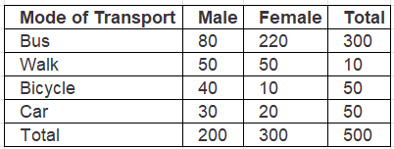

Does this data suggest that males and females use different modes of transport to get to college?

The test variable in this example is the mode of transport, which is a Nominal variable. We are examining the difference between two groups - males and females, so the appropriate test is the chi-square test.

This test is a little more complex than the Z-test and involves three steps.

**Step 1** 🡺 **State the null and alternative hypotheses:**

* H0: Males and Females use the same modes of transport to get to college.
* H1: Males and Females do not use the same modes of transport to get to college.

**Step 2** 🡺 **Calculate the Expected values**

So the **Expected E** values are the values we would expect to get from the survey if the null hypothesis was true.

For instance, if there was no difference between males and females, how many males would we expect to take the bus? 300 students out of 500 take the bus, which is equal to 60%(.6) of the students, so if there was no difference between the genders, we would expect 60% of males and 60% of females to take the bus. So;

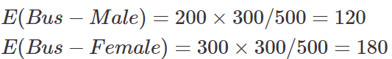

We can calculate the rest of the expected values using the same formula:

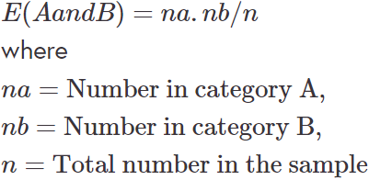

**Step 3** 🡺 **Calculate the chi-square value**

The next step is to calculate the difference between the values **observed Oi** in our survey and the expected theoretical values **Ei** using the following formula:

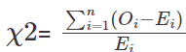

**The chi-square provides a measure of the average relative squared differences between the observed and expected values.**

A chi-square statistic is calculated in the code in the link below for the data outlined in Table 1 above. Have a look at this code and manipulate the data and see what happens.

<https://drive.google.com/open?id=1qn8ZZagr1zA5K12I25SwBp9RPrkXi0eg>

So let’s interpret these results:

The Chi2-stat is basically the statistic in the above formula.

The **degrees of freedom** is calculated by the following formula:

(Rows – 1).(Columns -1) = (4 – 1).(2 – 1) = 3

The p-value is really small and is <0.05. This tells us that the difference between males and females is well beyond what we would expect to get due to random chance. We can, therefore, reject the null hypothesis and accept the alternative, that there is a significant difference between males and females.

### Chi-Square Goodness of Fit Test

The makers of League of Lemurs say the popularity of characters chosen is:



The lemurs example is a goodness of fit test which tests how well certain proportions fit our sample. It only has one row or variable. We can have many categories but only looking at one variable: in this case character class.



H0 🡺 Given percentages are correct

H1 🡺 Given percentages are NOT correct

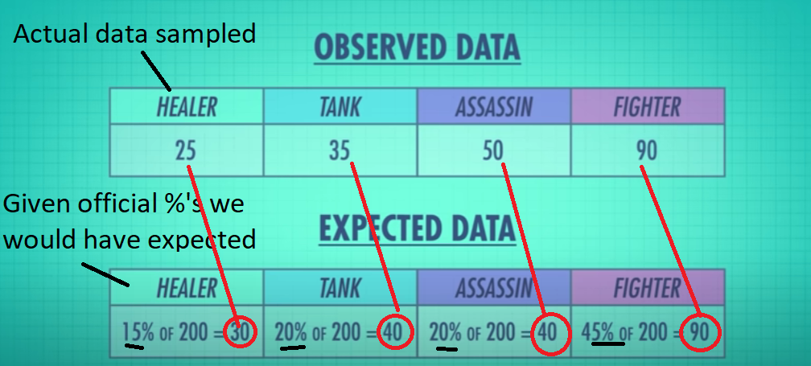

If we try to subtract the difference, then we’ll always end up with 0. Instead, let’s square the differences! Then add them all up.

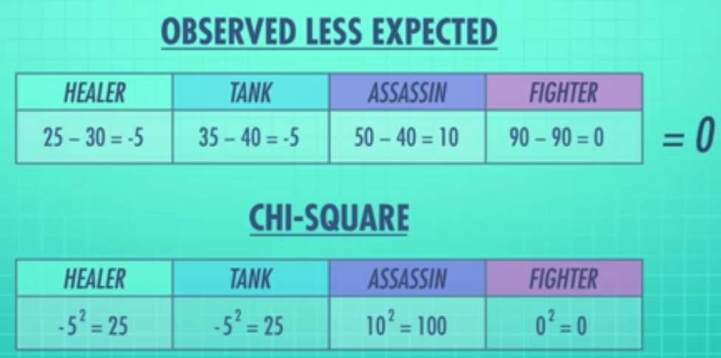

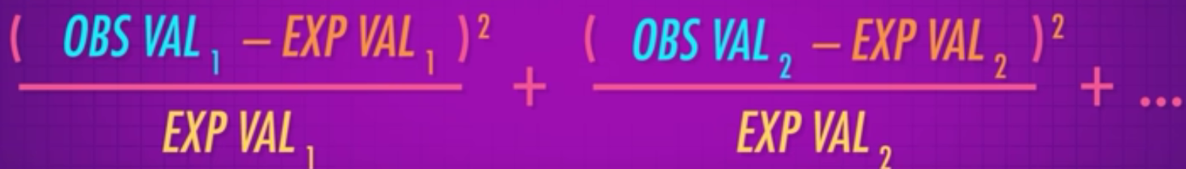

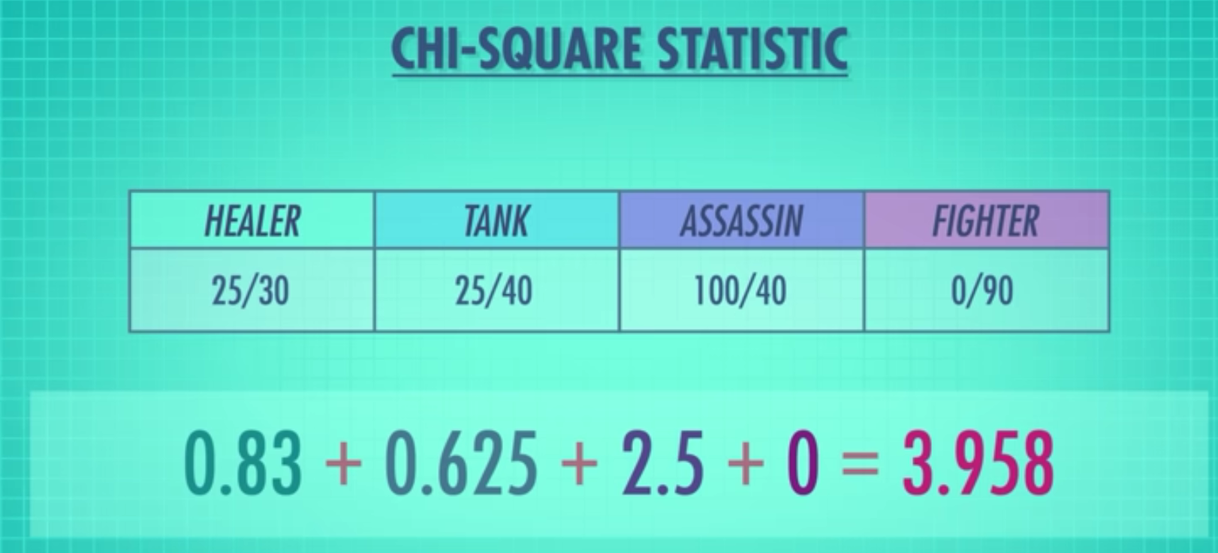

A chi square statistic has a distribution that we can use to find a p-value. The chi square distribution changes it shape as degrees of freedom change. We calculate our degrees of freedom to see which graph to use (in this case it’s 3) to look up our chi square statistic on.

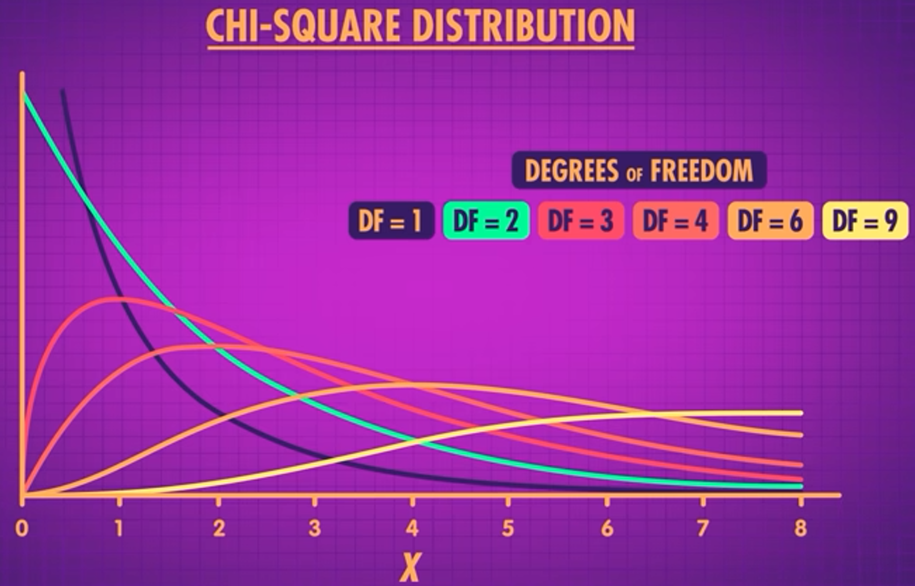

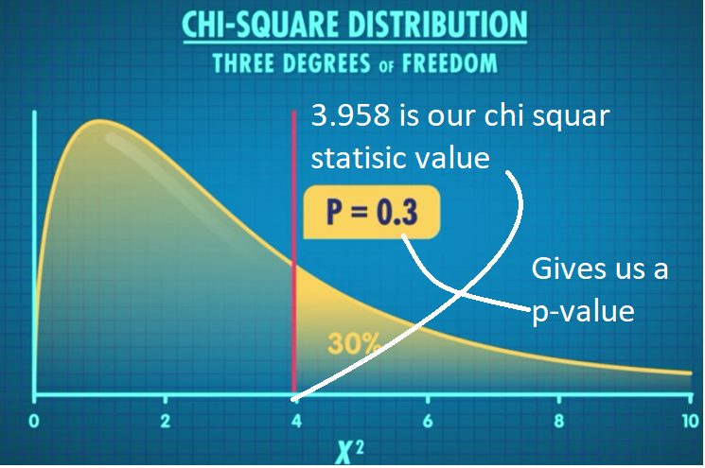

As p-value 0.3 > 0.05, we do NOT reject H0.

Goodness of Fit test can be represented as an **F-Score**.

### Chi-Square Test of Independence

Tests of independence look to see if being a member of one category is independent of being a member of another. E.g. Does liking Hawaiian pizza effect the probability of you identifying with each Hogwarts house… Gryffindor, Slytherin, etc?

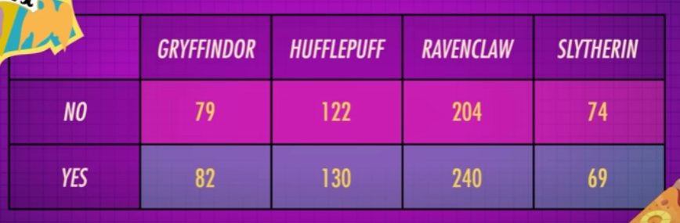

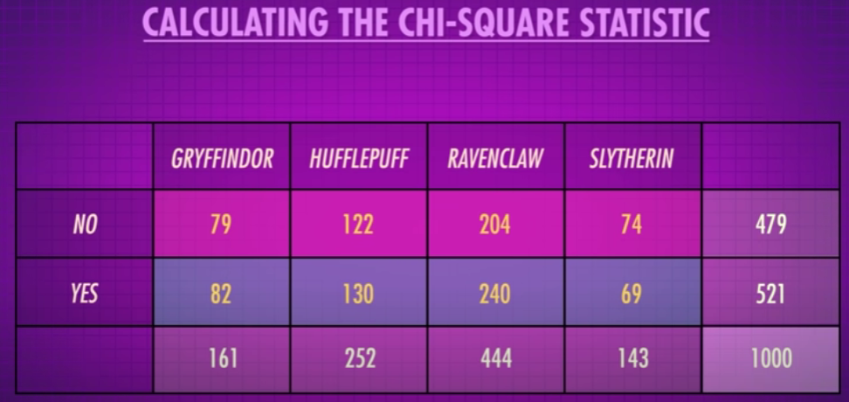

**Degrees of freedom = (Rows – 1)(Columns – 1) = (2 – 1)(3 – 1) = 3**

**H0:** The distribution of Hogwarts house is the same for both Hawaiian pizza lovers and haters.

Calculate our expected frequencies, based on Gryffindor and do the same for all…

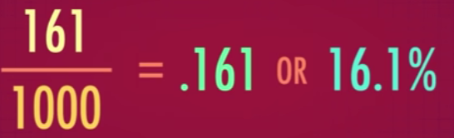

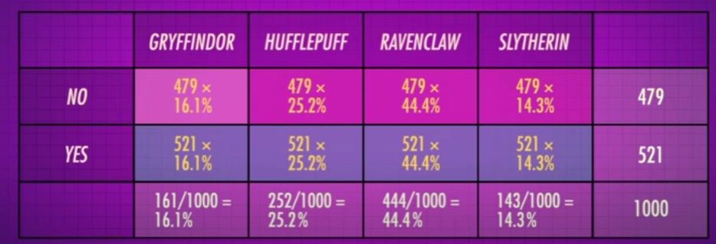

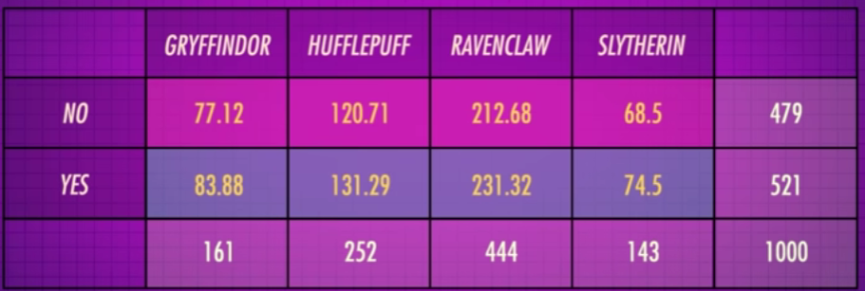

Use the chi square formula on each cell

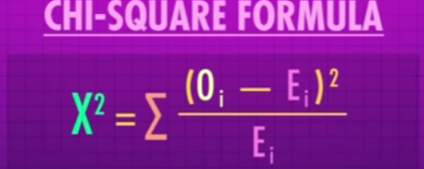

Then add them all up to get our chi square statistic…

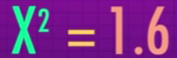

And look it up…

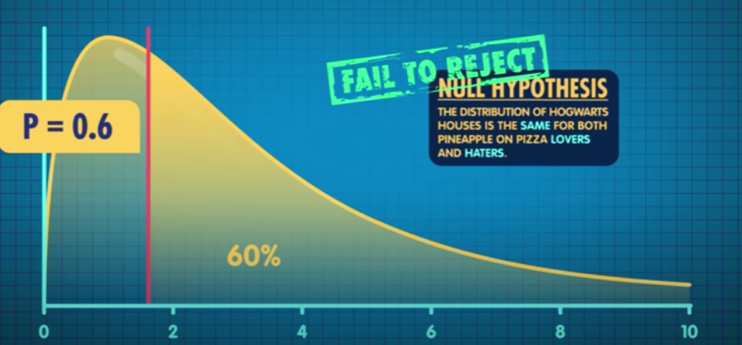

As p-value 0.6 > 0.05, we do NOT reject H0.

### Chi-Square Test of Homogeneity

This tests whether it’s likely that different samples come from the same population.

E.g. Are two samples of water from the same lake, based on the sample of algae, fish, pollution, etc?

## 3.8 Analysis of variance (ANOVA)

ANOVA stands for the **analysis of variance**. It is a test that is used throughout scientific research and there are many variations of it.

An **ANOVA is generally used when we are comparing more than two groups for an outcome variable**. In Step 3.4, we compared the means from two samples taken from two distinct groups. We used a t-test to determine if we would accept or reject the null hypothesis. Null hypothesis was “Average Salary is equal in both sectors”:

 or 

Alternative Hypothesis was ”Average Salary is not equal in both sectors”:

 or 

**With an ANOVA we are extending this principle at its simplest level to more than two groups**. So now our questions would be **‘Is the mean of each group the same?’** and our null hypothesis would be:



and the alternative implies that at least one mean is different from other groups:

*H1:* 

This is a one-factor analysis, and it can be extended to multi-factor studies with covariate variables, but more on this when we talk about Generalised Linear Models (GLM).

The ANOVA Assumptions are as follows:

* Residuals (experimental error) are **normally distributed** (Shapiro Wilks Test).
* **Homogeneity of variances** (variances are equal between treatment groups) (Levene or Bartlett Test). Opposite is heterogeneous, i.e. errors variance differing as x increases, in which case our model is wrong.
* Observations are **sampled independently** from each other.

### ANOVA test Example

Note: In ANOVA, group, factors, and independent variables are similar terms.

**Google Colab task**

Let’s look at a dataset which gives medical data for four different groups of patients. We are going to use Google Colab to examine if there is a difference between the 4 groups of patients. Each group has been given a particular cocktail of drugs. Follow the Google Colab file and you should get a good feel for the analysis required to complete an analysis of variance. Notice how we examine the assumptions? Make sure you are familiar with them as they can induce bias if they are not meet.

When you finish the activity on Google Colab, come back to the step and make sure to share your reflection on the task.

We have examined how we would compare more than 4 independent groups using an ANOVA across one variable/factor.

Can you find out if this can be done for more than 1 factor? Post your reply in the comments section below.

# Regression Modelling

## 3.9 Regression modelling - linear regression

In this section, we will introduce the concept of regression models, with a particular focus on linear and logistic regression. We will get into much more detail about regression modelling when we get to explore the Generalised Linear Models in the final course of the Data Analytics and Data Mining series. Throughout this section, we are going to use simple Python examples to show you how to conduct basic regression analysis, so every so often you will be directed to use Google Colab files.

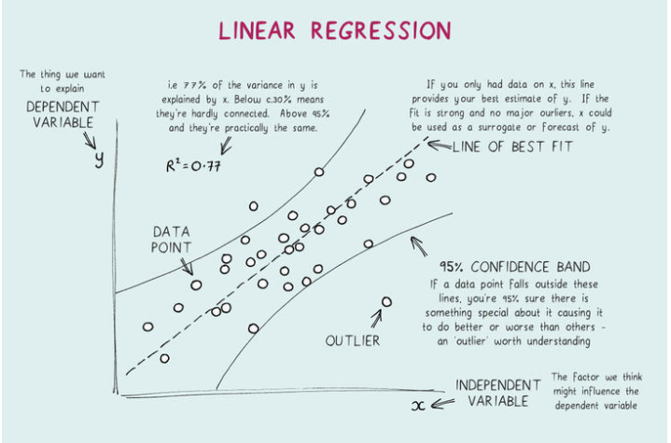

### Linear Regression

In many business research situations, the path to decision-making lies in understanding the relationship between two or more variables. For example:

* Can the price of airline stock be predicted using a variable like the cost of oil?
* How strong a relationship is there between a company’s sales figures and their advertising budget?

Regression Analysis is the process of constructing a mathematical model or function that can be used to predict one variable using another variable (simple linear regression) or variables (multiple linear regression). The basic idea is to **create a line of best fit in the data**, as shown in the graph below:

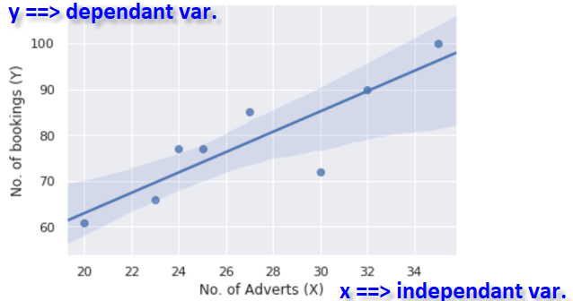

By linear, we mean that we have a function such as:

* ***yi = a + bxi + ei*** where ***i = 1 to n***
* ***yi*** is known as the dependent variable, e.g. “*no. of bookings*” above, and is generally the variable we are trying to predict and **is the row number in the dataset**.
* ***xi*** is the independent variable, e.g. “*no. of adverts*” above, and is the one we are using as a predictor variable.
* ***a*** is the intercept and is the expected mean when ***xi*** is zero. ***b*** is the slope or the rate of change in ***y*** for a unit increase in ***x***.
* ***ei*** “error term” is **independently normally distributed with a mean of 0 and a constant variance** aka homogeneity of variance.

**Look out for confounding variables!** Confounding variables are those that affect other variables in a way that produces spurious or distorted associations between two variables. They confound the "true" relationship between two variables. E.g. there seems to be a correlation between sunburn and ice cream consumption but the missing or confounding variable is actually temperature: ice cream consumption doesn’t increase sunburn levels, but temperature influences both variables.

The last point is extremely important in regression analysis and should not be forgotten.

Linear Regression can be considered as one of the most basic forms of machine learning or artificial intelligence. **It uses a method called maximum likelihood estimation** to come up with the most appropriate values of a and b. It does, however, assume that **the error term is independently normally distributed with a constant variance**.

From a data mining position, we will use it in a number of ways and they are as follows:

* Predict missing values.
* Identify important features in a dataset.
* Understand if there are hidden features.

The wonderful thing about linear regression is that we can easily understand the impact independent variables have on the outcome or dependent variable. The drawback is that **things can go very wrong if we break the assumptions such as normality of the error or the consistency of the error variance**. These are important issues and should not be overlooked.

It is also worth framing in your mind the idea of ***yi = a + bxi + ei*** as a basis for all prediction problems. I appreciate we cannot predict all variables with one input or independent variable or the assumption that the functional structure is linear, but when you try to solve a problem it is always good to try and ask yourself what are the output/dependent and input/independent variables.

### Google Colab Task - Fedbus Example

Fedbus have been using radio advertisements to advertise their weekend excursions for the past 8 months. The managing director has asked the sales team to assess the effect of these ads on the number of bookings.

The example data for this example can be found here:

<https://drive.google.com/open?id=1w4mpBr7uQHi4sy-6InCdUCPfZgILijEGPUwOZzuCPD4>

**Note:** Follow the instructions in the Google Colab:

<https://drive.google.com/open?id=1fqsmTZ2YDqX_8uOB7CgiZdVPL1ueDSZz>

and you will understand how to read the data from the example data. You will also be able to complete a basic regression analysis to understand it effects booking numbers. You will need to save the data to your own Google Drive.

If that proves difficult, you might find this post on [www.towardsdatascience.com](http://www.towardsdatascience.com) helpful. It explains three ways to load CSV files into Colab:

the data to your own Google Drive.

<https://towardsdatascience.com/3-ways-to-load-csv-files-into-colab-7c14fcbdcb92>

Regression coefficient

**Regression** **coefficients** are estimates of the unknown population parameters and **describe the relationship between a predictor variable and the response**. **Regression coefficient is comparable to slope.** In linear regression, coefficients are the values that multiply the predictor values. Suppose you have the following regression equation:

y = 3X + 5

In this equation:

1. Coefficient = +3
2. X = the predictor
3. +5 = constant

The sign of each coefficient indicates the direction of the relationship between a predictor variable and the response variable. For example, if a coefficient is +3, the mean response value increases by 3 for every one unit change in the predictor.

**Positive +** 🡺 As the predictor variable increases, the response variable also increases.

**Negative -** 🡺 As the predictor variable increases, the response variable decreases.

### Coefficent of determination

There is a term called the **coefficent of determination** **or goodness of fit** a.k.a. **R2** which is a measurement used to explain how much variability of one factor can be caused by its relationship to another related factor.

R2 is used to quantify the amount of variability in the data that is explained by your model, whereas the Chi-square goodness of fit test is used to test if your data follows a particular distribution. R2 is useful for comparing the fits of different models.

Generally (but not always!), a higher coefficient indicates a better fit for the model. For example this R2 of 75% means that 75% of the data fit the regression model. This is just a single measure and can be misleading but it is a measure that can guide you if your model is going in the right direction. However, be warned don't expect a high R2 to give you good predictions.

### Giude for building your model

* **Graph the errors** against the predicted and the actual dependent variable.
* Use a combination of **AIC**, **BIC** and **p** **values** to make a decision about reducing or increasing the number of independent variables.
* If then intercept is insignificant, i.e. > 0.05, then we may be able to discount it altogether. However, in order to that, first we need to check the AIC and BIC values *with* Vs *without* intercept (using python formula Y~0+X). If the difference is insignificant, then we “can in theory” disregard intercept. But in practice we generally only disregard the intercept when it goes through the origin (0,0).
* Use **R2**(coefficent of determination) with caution – it can mean your model is overfitted. A bit of error or residual noise is not a bad thing.
* Examine the **Durbin Watson** statistic and **Jarque-Bera** statistic to establish if the errors are independent.
* P-value significance: < 0.05 is significant
* Jarque-Bera (probability) is a test that tells you how far from normal your errors are. JB of < 0.05 is significant, i.e. errors are not normally distributed.
* Durbin Watson significance: NOT in range 1.5 to 2.5 is significant

### Predictive, independent and dependent variables

E.g. using class attendance to predict grade average, attendance is the predictor variable (X-axis) and grade average is the response variable or dependent variable (Y-axis). Predictor variables are different to independent variables but can be confused with them.

Predictor variables cannot be used to determine cause.

Independent variables cant be used to determine cause and are manipulated by the researcher.

## 3.10 Regression exercise

It is time for some hands-on activity. In this step, I have a real-life example and data that I would like you to play with.

A survey on the prestige of Canadian citizens concerning their occupation can be found on the R-datasets:

<https://stat.ethz.ch/R-manual/R-devel/library/datasets/html/00Index.html>

The R-datasets is a library of datasets that are accessible to the R and Python programming languages. In this example, you will read an R dataset into Google Colabs using this code:

<https://drive.google.com/open?id=1ZICTACvKWPeVUDLLtR7_OnyVTj46AkSf>

Now use the linear regression from statsmodels to determine which variables have a potential impact on prestige.

**Note:**

* you will have to use more than one independent variable in your model.
* for this exercise leave out the type and census variables.

When you have completed your analysis, answer the questions in Step 3.11. The solution to this exercise is available here.

This exercise is designed to help you understand a simple regression analysis. This is not part of the continuous assessment but I suggest you talk as a group and discuss if there was anything challenging.

## 3.11 Quiz

**Question 1** – Which of the 3 independent variables should be in the model?

* Education, income and women.
* Women and income.
* Education and income.
* Education and women.
* Not sure.

**Question 2** – Which metrics did you use to determine the right model?

* AIC, BIC and P-values.
* AIC, BIC, P-values & R-squared.
* R-squared.
* I don’t know.

**Question 3** – Is the assumption that errors are independent of each other met?

* Yes.
* No.

**Question 4** – Pick the most appropriate reasons for question 2.

* Durbin Watson is 1.687.
* The Jargue-Bera P-value is not significant.
* Durbin Watson for the model with income and education is 1,687.
* The plot of predicted against the error is well distributed.

**Question 5** – How do you show the normality of the error assumption is met?

* The Jarque-Bera P value is greater than 0.05
* The Durbin-Watson is > 1.5

**Question 6** – What transformation would improve the model?

* None Exists.
* Getting the natural log of income would help.

## 3.13 Regression modelling - logistic regression

We have now recapped on inferential statistics, analysis of variance and linear regression. One of the other things that students always want to know is how do I model categorical variables, or how do I classify a piece of data.

Logistic regression is one of the simplest classifiers. I will give a quick introduction to it in this section.

Form of regression that allows the prediction of discrete variables by a mix of continuous and discrete predictors who job it is to proves if the independent variable does or does not cause changes in the dependent variable.

The objective of basic logistic regression is to model binary outcomes. In linear regression, we modelled continuous outcomes such as sales or prices with independent variables. Logistic regression is used to model the probability of a categorical outcome/dependent variable. This variable will have two options which are either a 1 or a 0, and the logistic regression model will attempt to predict P(Y=1) as a function of X.

### The Logistic Regression Assumptions

* Binary logistic regression requires the dependent variable to be binary.
* For a binary regression, the factor level 1 of the dependent variable should represent the desired outcome.
* Only meaningful variables should be included. The independent variables should be independent of each other. That is, the model should have little or no multicollinearity. **Multicollinearity occurs when a linear combination of one or more independent variables is collinear with another variable, e.g. height and weight, education and income.** This characteristic has a habit of inflating the variance of the parameter estimate in question and can lead one to wrongly accept the null hypothesis, or that the variable is not significantly different from zero.
* The independent variables are linearly related to the log odds.
* Logistic regression requires quite large sample sizes.

**Example - Google Colab activity**

Keeping the above assumptions in mind, let’s look at a dataset. In this dataset we want to determine which of the three independent variables affects the success rate of people applying for a specific position:

* Graduate Management Admission Test score
* GPA score
* Work experience

We will read the data into a dataframe called candidates and then conduct a multivariate logistic regression. Wow! That’s a mouth full. It’s pretty similar to the linear regression exercise you completed. The only difference is you have a binary class as a dependent variable, Open the Google Colab file:

<https://drive.google.com/open?id=1J1VnpS58nDXiF1XPFPXXKw6xbUxhNxSj>

Follow the steps and make sure you play with the models. Google Colab is very clear about the interpretation of the results.

Also, pay particular attention to the evaluation metrics in the analysis. These metrics are predominantly used when assessing classifiers. At the end of this step, you should be able to complete a simple classifier problem.